

**Tracking and Pose Estimation of a Robotic System using Computer Vision**

*Karl Spiteri*

*Supervisor: Dr Ing. Jeremy Scerri*

*May 2024*

A dissertation submitted to the Institute of Engineering and Transport in partial fulfilment of the requirements for the degree Bachelor of Engineering (Honours) in Control and Electronics

Engineering.

# Authorship Statement

This dissertation is based on the results of research carried out by myself, is my own composition, and has not been previously presented for any other certified or uncertified qualification.

The research was carried out under the supervision of Dr Ing. Jeremy Scerri.

20th May 2024

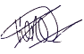  
________________

# Copyright Statement

In submitting this dissertation to the MCAST Institute of Engineering and Transport, I understand that I am giving permission for it to be made available for use in accordance with the regulations of MCAST and the College Library.

20th May 2024

  
________________

# Acknowledgements

Thank You to my supervisor, friends, and family who supported me throughout my thesis. Their support, encouragement, and faith in me were significant. Their support helped me overcome obstacles and hurdles I encountered.

# Abstract

This thesis presents a comprehensive approach to tracking and pose estimation of a robotic arm using computer vision techniques. The primary goal of the research is to develop a real-time computer vision system capable of tracking the robotic arm, estimating its joint angles, and providing a live virtual prototype of the robotic arm.

The development process involved several key steps. Firstly, a tracking system was constructed to enable robust custom object tracking. This involved implementing algorithms for feature detection, matching, and tracking to accurately follow the movement of the targeted object. Additionally, a marker generator was built to create unique markers tailored to the robotic arm. These markers were designed to provide distinct visual features for reliable pose estimation.

To ensure precise marker placement on the robotic arm, 3D printed custom designed placers were designed using CAD techniques. These placers were custom designed to fit the specific dimensions and geometry of the robotic arm, facilitating accurate marker positioning. The markers were strategically placed on the arm to enable precise joint angle estimation.

Marker data acquisition was a crucial step in the process. The computer vision system read the marker data and extracted the necessary matrices for subsequent calculations. These matrices contained essential information about the position, orientation, and motion of the markers, allowing for further analysis.

Using the data from the markers further calculations would lead to achieving the joint angles of the robotic arm. Then kinematic techniques can be applied to construct a live virtual prototype of the robotic arm in real-time therefore having a visual representation.

# Contents

Authorship Statement ii

Copyright Statement iii

Acknowledgements iv

Abstract v

Contents vi

List of Figures ix

Glossary of Terms xi

List of Abbreviations xiii

1. Introduction 1

2. Literature Review 4

2.1 Tracking Techniques in Computer Vision 4

2.1.1 Traditional Tracking Approaches 5

2.1.2 Deep Learning-based Tracking Techniques 8

2.2 Computer Vision Marker Based Pose Estimation in Robotics 10

2.2.1 Marker Systems & Calibration Techniques 12

2.2.2 Comparative Review of Kinematic Models in Robotics 16

3. Research Methodology 20

3.1 Analysis of TensorFlow API for Custom Object Detection 20

3.2 Construction of a Custom Object Detection Pipeline 21

3.2.1 Data Collection: 21

3.2.2 Image Annotation: 21

3.2.3 Dataset Split: 23

3.2.4 Generate CSV Files: 23

3.2.5 Generate TF Records: 24

3.2.6 Transfer Learning: 24

3.2.7 Training: 25

3.2.8 Model Evaluation & Export: 26

3.3 Marker Selection & Generation 27

3.4 Marker Placement and Design 28

3.5 Camera Calibration 29

3.5.1 ArUco Marker Data Extraction 32

3.6 CAD Augmentation 33

3.7 Live Virtual Prototype using DH Parameters in MATLAB 35

3.8 Block Diagram of The Overall System 37

3.9 Flowcharts 37

4. Analysis of Results and Discussion 41

4.1 Initial Testing 41

4.2 Tracking Testing 43

4.2.1 Tracking ArUco markers 43

4.2.2 Tracking of Robotic Arm 45

4.2.3 Analysis of tracking model 47

4.3 Pose Estimation 49

4.3.1 Testing Accuracy 50

4.4 Final Result 55

5. Conclusions and Recommendations 57

5.1 Overview 57

5.2 Achievements 58

5.3 Improvements 59

References 61

Appendix A Marker Generation Script 63

Appendix B – Camera Calibration Script 66

Appendix D – Server Webcam Feed Script 68

# List of Figures

Figure 1: Kalman Filter (KF) Results [1]. 6

Figure 2: Particle Filter Approximation Results [2]. 7

Figure 3: Comparison of Tracking Results Between Kalman Filter and Particle Filter [3]. 8

Figure 4: Performance of deep learning model [4]. 9

Figure 5: Qualitative detection between SSD and YOLOv3 [5]. 10

Figure 6:Results of accuracy due to camera calibration [6]. 13

Figure 7: Accuracy of pose estimation of a marker-based system [7]. 14

Figure 8: Different angle reading of different fiducial markers [8]. 15

Figure 9: Coordinate frame assignment for a planar manipulator [9]. 17

Figure 10: Four positions for a planar manipulator [9]. 18

Figure 11: Coordinate frame and unit line vectors [9]. 19

Figure 12: LabelImg software to track the required pixels. 22

Figure 13: Randomizing the data split to be utilized for training and testing. 23

Figure 14: Utilizing a Python script to generate TF records. 24

Figure 15: Transfer learning parameters set for the training. 25

Figure 16: Custom Object Detection Pipeline Example for the forementioned steps [14]. 26

Figure 17: ArUco Markers with different matrix size [15]. 28

Figure 18: CAD model of end-effector marker placement. 29

Figure 19: Design implemented on end-effector. 29

Figure 20: A1 ChArUco Board (5x7) 30

Figure 21: A3 ChArUco Board (5x7) 31

Figure 22: Camera matrix and distortion coefficients. 32

Figure 23: Extracted pose angles. 33

Figure 24: 3D Printed Augmenting Shaft 34

Figure 25 Augmentation on the Robotic System 34

Figure 26 Live Virtual Prototype 36

Figure 27: Block Diagram of The Overall System 37

Figure 28: Client System Flowchart 37

Figure 29: Vision System Flowchart Part 1 38

Figure 30: Vision System Flowchart Part 2 39

Figure 31: MATLAB System Flowchart 40

Figure 32: ArUco marker Vector X set at 0°. 44

Figure 33: ArUco marker Vector X set at 60°. 44

Figure 34: Detection of multiple ArUco markers with change in all Vectors. 45

Figure 35: Tracking the robotic arm unobstructed. 46

Figure 36: Tracking robotic arm obstructed. 46

Figure 37: Loss of machine learning model over epochs. 48

Figure 38: Robot tracking and angle tracking of joints from one side. 49

Figure 39: Robot tracking and angle tracking of joints from another side. 50

Figure 40: 3D prints used to make the testing apparatus. 51

Figure 41: Robotic arm with test setup. 51

Figure 42: Application of spirit bubble to keep test setup level. 52

Figure 43: Reading the angle of movement of the elbow marker. 53

Figure 44: Elbow average from multiple tests. 54

Figure 45: Shoulder average from multiple tests. 55

Figure 46: Pose estimation and tracking followed with real-time representation on MATLAB. 56

# Glossary of Terms

API: Application Programming Interface - A set of rules and protocols that allows different software applications to communicate and interact with each other.

CAD: Computer-Aided Design - The use of computer software to create and modify designs, typically for engineering, architectural, or manufacturing purposes.

CNN: Convolutional Neural Networks - A class of deep neural networks designed to process structured grid-like data, such as images or video, using convolutional layers for feature extraction.

CSV: Comma-Separated Values - A simple file format used to store tabular data, where each value is separated by a comma. It is commonly used for data interchange between different software applications.

DH: Denavit-Hartenberg - A convention used in robotics to represent the geometric transformations and kinematics of robotic manipulator systems.

MAP: Mean Average Precision - A metric commonly used to evaluate the accuracy of object detection and segmentation models by measuring the precision and recall of the predicted results.

RCNN: Region-based Convolutional Neural Networks - A family of object detection algorithms that generate region proposals and use convolutional neural networks to classify and refine the proposed regions.

RESNET: Residual Network - A deep neural network architecture known for its residual connections, which allow for training very deep networks by addressing the vanishing gradient problem.

SSDS: Single Shot Detectors - A type of object detection algorithm that predicts bounding boxes and class labels in a single pass through the network, making it efficient for real-time applications.

TFRECORD: TensorFlow Record - A file format used for storing large amounts of data in

YOLO: You Only Look Once - An object detection algorithm that processes the entire image in a single pass, making it efficient for real-time applications and known for its fast inference speed.

# List of Abbreviations

API Application Programming Interface

CAD Computer-Aided Design

CNN Convolutional Neural Networks

CSV Comma-Separated Values

DH Denavit-Hartenberg

MAP Mean Average Precision

RCNN Region-based Convolutional Neural Networks

RESNET Residual Network

SSDS Single Shot Detectors

TFRECORD TensorFlow Record

YOLO You Only Look Once

# Introduction

**In recent years, remarkable advancements in robotics have enabled robotic systems to accomplish complex tasks with extraordinary precision. Among these tasks is the capacity for real-time tracking and position estimation of robotic arms, which is essential for enhancing their interaction with the environment.**

**This thesis aims to explore robotic systems by creating a computer vision system with the capability for real-time object tracking and the estimation of joint angles for a robotic arm. In addition to this, the system incorporates the acquired data to generate a live virtual prototype of the robotic arm within the MATLAB environment, offering a visually intuitive representation of its structure and dynamic movements. Through the combination of computer vision and robotics, this research is aimed to amplify the capabilities of robotic arms and elevate their proficiency in engaging with the surrounding world.**

**Achieving a real-time object tracking requires the deployment of robust algorithms that can handle through occlusions, accommodate variations in lighting conditions, and adapt to diverse object appearances. Likewise, the precision of joint angle estimation for the robotic arm necessitates the fusion of visual data with intricate kinematic models.**

**To address these challenges, this thesis uses a systematic approach. A tracking system is carefully created, using advanced computer vision algorithms for feature detection, matching, and tracking. Custom Augmentations and modifications for the robotic arm are designed with CAD software. These include custom marker placers and mechanical improvements, aimed at achieving precise and reliable pose estimation.**

**The key part of this system is collecting marker data, which is crucial for its operation. The computer vision system interprets this data, extracting essential matrices that provide information about the markers' orientation, position, and motion. These matrices are used for further calculations, allowing for precise estimation of joint angles and real-time tracking of the robotic arm's position.**

**The impact of this research is significant and wide-ranging. Developing a strong computer vision system for tracking and pose estimation of robotic arms could transform many fields, including industrial automation, healthcare, and exploration. By giving robotic arms the ability to accurately understand and interpret their surroundings, this research marks a new era of enhanced autonomy and efficiency, enabling better collaboration and interaction between humans and robots.**

**In summary, this thesis introduces a new approach to tracking and pose estimation for robotic arms by effectively integrating computer vision techniques. The resulting system not only tracks objects and estimates joint angles but also provides real-time, dynamic visualization of the arm's movement. This blend of computer vision and robotics promises to improve and expand the capabilities of robotic arms.**

# ****Literature Review****

## Tracking Techniques in Computer Vision

The aspect of computer vision has witnessed an exceptional growth over the past few decades. A central focus has been about the tracking of objects or features within images or videos, a task that has undergone remarkable revolution both in terms of methodologies employed and the achieved outcomes.

In the early days of computer vision, object tracking mainly used template matching. This involved sliding a template of the target object across each frame to find the best match. Although simple in theory, this method was computationally expensive and struggled with objects that changed appearance, orientation, or scale. Additionally, early tracking methods had difficulties with static backgrounds and limited object movement.

Recently, tracking techniques have improved immensely by combining machine learning, and deep learning. The start of these advancements where algorithms such as Mean Shift, Kalman Filters, and Particle Filters. More modern techniques are models like Single Shot Detectors (SSDs), Convolutional Neural Networks (CNNs), and You Only Look Once (YOLO), enabling real-time, efficient, and highly accurate object detection and tracking.

These advancements in tracking methods are crucial for robotic systems. In various fields, from autonomous driving to warehouse automation, robots need precise tracking to navigate, interact with objects, and understand gestures. In constantly changing environments, robust tracking allows robots to make informed decisions, respond to unexpected obstacles, and perform tasks accurately.

Overall, the development of tracking techniques in computer vision has been transformative. From basic pattern matching to advanced AI-driven algorithms, the ongoing improvement of tracking technologies is essential for the future of intelligent and responsive robotic systems.

### Traditional Tracking Approaches

In position estimation, especially in complex and unstructured environments, two key algorithms stand out: the Kalman Filter and the Particle Filter. These probabilistic algorithms provide precise tracking capabilities across various applications [1] [2].

The Kalman Filter is well-known for its optimal use of the Bayes estimator, making it ideal for linear systems with Gaussian noise [1]. It works through a recursive two-step process: prediction and correction. The Kalman Filter requires a model and is very effective when the system's behaviour is linear [1]. However, it becomes more complicated when tracking multiple objects, requiring an association algorithm to ensure accurate input for the estimator [1]. *Figure 1* highlights the improvement of the Kalman filter (Blue) when comparing the Internal Navigation System (INS) (Red) and the reference of the GPS (Green).

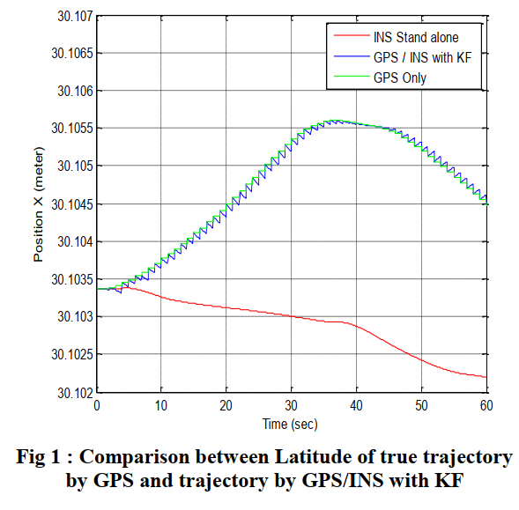

Figure 1: Kalman Filter (KF) Results [1].

In contrast, the Particle Filter offers a flexible approach that is ideal for nonlinear and non-Gaussian environments [2]. Unlike the Kalman Filter, the Particle Filter doesn't discretize the state vector, leading to more accurate estimations [2] and lower computational load, making it suitable for real-time estimation. This attribute also translates into a reduced computational load, rendering the Particle Filter eminently suitable for real-time estimation. A key feature of the Particle Filter is its ability to include multiple estimation hypotheses within a single algorithm, something the Kalman Filter cannot do [2]. As depicted in *Figure 2* Particle filter is used to for camera tracking where the weighted particle shows a potential location for the camera.

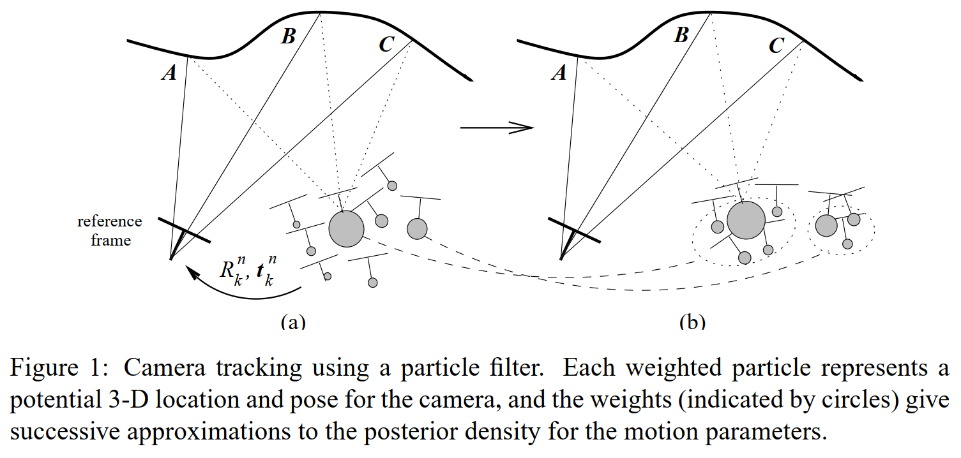

Figure 2: Particle Filter Approximation Results [2].

When comparing these filters for multi-object tracking, the Particle Filter was extended and adapted with a clustering process to track multiple objects. On the other hand, the Kalman Filter used an association algorithm for each object [3]. Real-time tests showed that both filters have distinct advantages and limitations in different applications. This could be observed in *Figure 3*.  
  
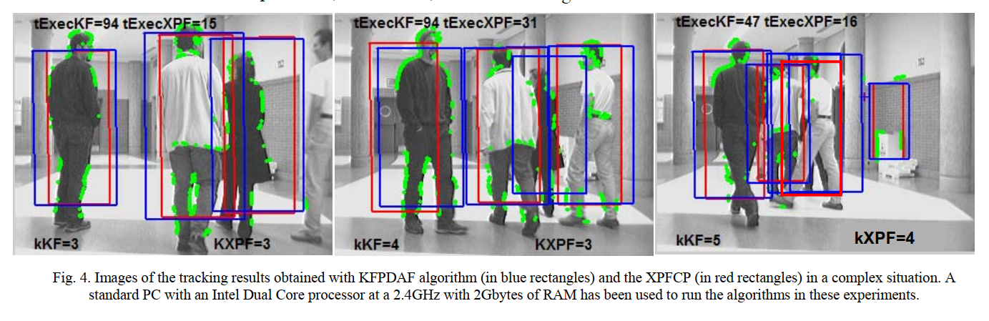

Figure 3: Comparison of Tracking Results Between Kalman Filter and Particle Filter [3].

### Deep Learning-based Tracking Techniques

Deep learning has revolutionized object detection with models like Single Shot MultiBox Detector (SSD), You Only Look Once (YOLO), and RetinaNet. These models are widely used in real-time object detection.

Findings from [4] have shown connections between these models. RetinaNet achieved a high mean average precision (MAP) of 82.89% but had a frames per second (FPS) rate only one-third of YOLO v3, making it less suitable for real-time use. SSD was competent but did not excel in either MAP or FPS metrics. YOLO v3, with a slightly lower MAP score of 80.69%, had a significant advantage in detection speed and performed better with complex samples, making it suitable for applications like hospital equipment [4]. This could be observed in *Figure 4*.

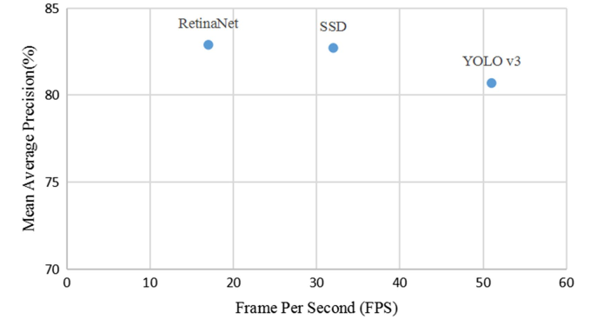

Figure 4: Performance of deep learning model [4].

Another study compared SSD and YOLO in detecting outdoor urban advertising panels under various environmental conditions. This research found that SSD nearly eliminated False Positive cases, which is useful for analysing the content of detected panels. However, YOLO had better panel localization, detecting more True Positive panels with higher accuracy [5]. This could be seen in *Figure 5*.

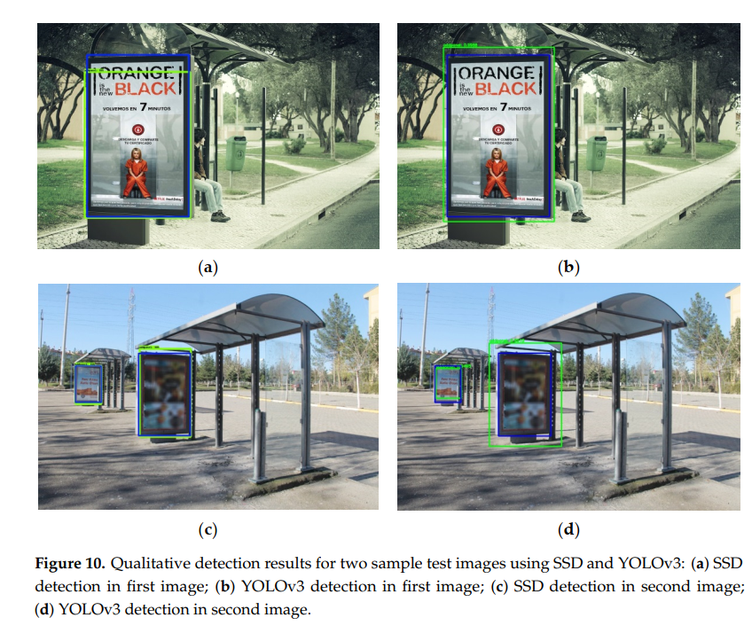

Figure 5: Qualitative detection between SSD and YOLOv3 [5].

## Computer Vision Marker Based Pose Estimation in Robotics

For computer vision it is very important to precisely determine an object's position and orientation. This is because precise pose estimation is essential for a robot to interact effectively within its surroundings.

Marker-based systems use strategically placed markers on a robot or the object of interest. These markers are typically 2D patterns or complex 3D structures, designed for easy detection by cameras or optical sensors. Once detected, the spatial information from these markers is transformed into a detailed representation of the object's pose.

For determining joint angles in robotics, markers are placed on the robot's joints or limbs. As the robot moves, cameras track these markers, and algorithms calculate the spatial relationships between them. These provide insights into the robot's orientation and movement patterns. By analysing the changes of these markers, the robot's joint angles can be deduced. This makes marker-based systems valuable for precise control of robotic arms or humanoid robot movements.

While the concept of markers is simple, the algorithms that interpret the captured data are complex. These algorithms handle challenges such as occlusion, where one marker blocks another, and changes in lighting conditions that affect marker visibility.

In summary, marker-based pose estimation is a vital tool in robotics, offering a robust and user-friendly way to determine object pose. By analysing the relative positions and orientations of markers, especially on robotic joints, we gain detailed insights into robot kinematics, enabling more precise control of robotic systems.

### Marker Systems & Calibration Techniques

Pose estimation is crucial in robotics and computer vision, enabling systems to understand their spatial orientation and position in their environment. Marker systems play a key role in achieving precise pose estimations, with calibration techniques ensuring accuracy and reliability in the process.

The referenced paper in [6] highlights marker-based methods, emphasizing the importance of calibration, especially when using multiple cameras. Calibration ensures that pose estimations from the markers are accurate across all cameras in the system. The results of this calibration process, shown in Figure 6, illustrate both the detailed procedure and its significant impact.

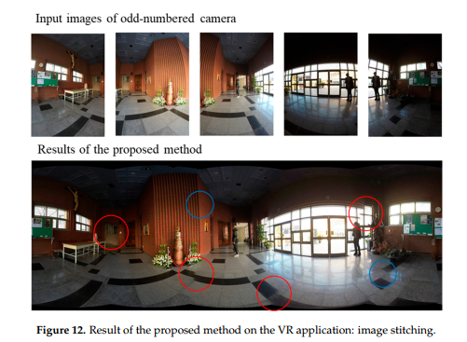

Figure 6:Results of accuracy due to camera calibration [6].

In the referenced paper [7], marker-based pose estimation uses identifiable markers on instruments to determine their position and orientation from captured images. This method shows promise for controlling endoscopic instruments but is influenced by several factors. Occlusions can hide markers, causing inaccuracies. Shadows, reflections, and lighting changes can interfere with consistent marker detection, leading to pose estimation errors. Calibration is crucial; inaccuracies in camera parameters can cause systematic errors. The geometric arrangement of markers is also important; markers that are too close together or poorly configured may limit accurate pose estimation, especially during rotations. Rapid instrument movements can challenge consistent marker tracking, introducing temporary errors. The method's accuracy was evaluated against an X-ray imager's ground truth, with RMS errors indicating its precision. However, these errors can vary based on the mentioned challenges. Figure 7 shows this accuracy. Overall, while marker-based estimation provides structured pose determination, its effectiveness depends on addressing these inherent challenges.

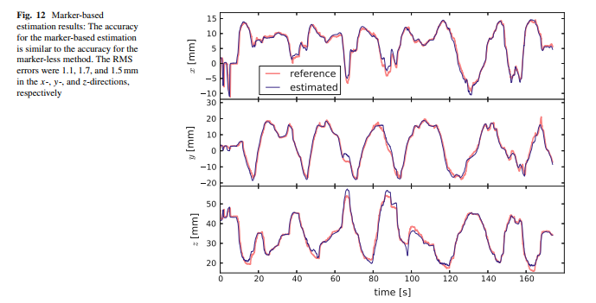

Figure 7: Accuracy of pose estimation of a marker-based system [7].

Lastly, the referenced paper in [8] provides a thorough analysis of fiducial markers. These markers, with known sizes and shapes, often feature distinctive black and white patterns, though some versions use various colours. The paper notes that while coloured markers can be detected faster, their accuracy decreases with greater distances and varying angles. The paper introduces STag, a fiducial marker package that emphasizes stable pose estimation measurements. STag markers have a unique circular pattern that refines initial homography through elliptical fitting. The results of their extensive research, shown in Figure 8, highlight the markers used, including ARTag, AprilTag, ArUco, and STag, each contributing uniquely to pose estimation.

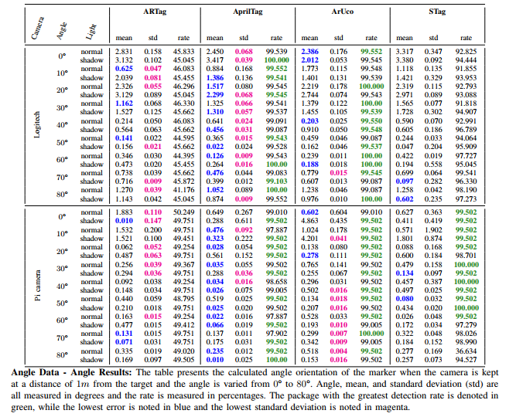

Figure 8: Different angle reading of different fiducial markers [8].

In summary, these works highlight the crucial importance of marker systems and their calibration techniques in pose estimation. Through detailed research, experimentation, and visual representation, they pave the way for improved precision and accuracy in understanding the spatial orientation and positioning of objects in robotics and computer vision.

### Comparative Review of Kinematic Models in Robotics

A fundamental aspect of robotics is understanding and modelling robot motion through kinematic models. This review contrasts three kinematic models which are: the forward kinematics, the inverse kinematics, and the Denavit-Hartenberg parameters [9] [10] [11].

Forward kinematics is a method of calculating the position and orientation of a robot's end-effector based on its joint angles and link lengths. Its benefits include straightforward computation without iterative methods, making it useful for simulating and visualizing robot motion. Figure 9 illustrates this with a co-ordinate frame assignment for a planar manipulator.

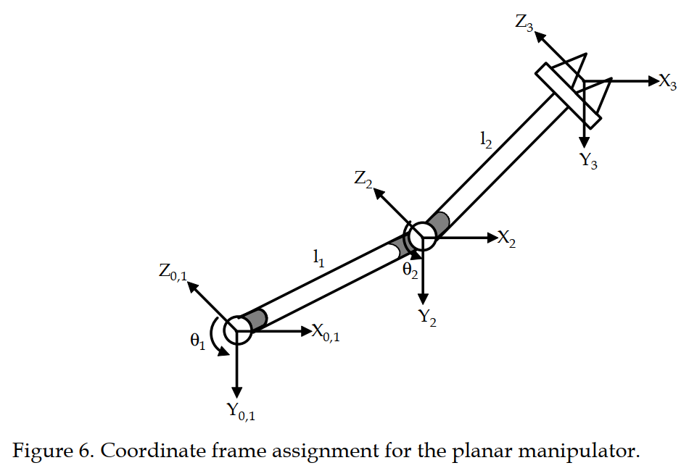

Figure 9: Coordinate frame assignment for a planar manipulator [9].

Inverse kinematics is the reverse of forward kinematics. It calculates the joint angles needed to achieve a desired position and orientation for the end-effector [10]. This method is important for path planning and control, allowing precise end-effector positioning. However, it can be challenging [9] due to the possibility of multiple solutions for a given position and configurations that may have no solution. Figure 10 shows four positions for a planar manipulator, highlighting inverse kinematics' complexities.

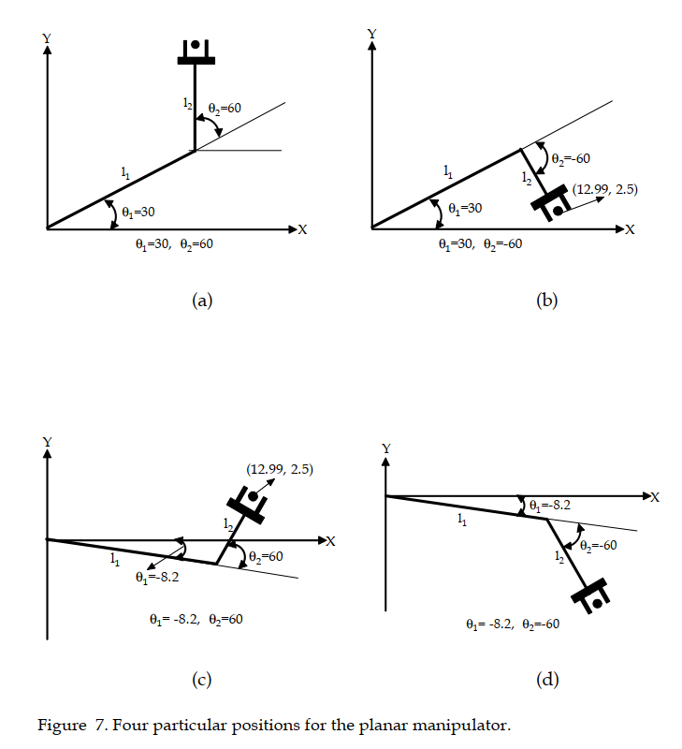

Figure 10: Four positions for a planar manipulator [9].

The Denavit-Hartenberg parameters provide a systematic way to define the geometry of robot manipulators. This method simplifies the transformation between link frames using four parameters: link length, link twist, link offset, and joint angle. Its benefits include a standardized way to represent robot kinematics and reduced complexity of transformation matrices [11]. Figure 11 depicts the coordinate frame and unit line vectors for the Stanford Manipulator, illustrating the application of these parameters.

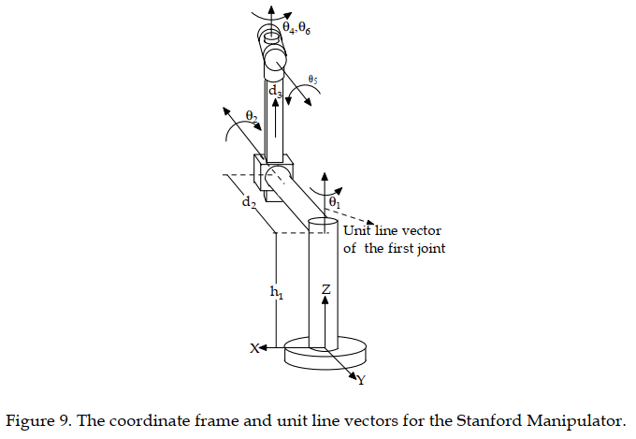

Figure 11: Coordinate frame and unit line vectors [9].

In conclusion, understanding robot kinematics is essential for their design, control, and operation. Forward kinematics directly determines the end-effector's position, while inverse kinematics controls the robot's motion based on desired positions. The Denavit-Hartenberg parameters offer a standardized way to represent the robot's geometry. Together, these models are fundamental for analysing and controlling robot motion.

# ****Research Methodology****

## Analysis of TensorFlow API for Custom Object Detection

TensorFlow a deep learning framework developed by Google, is open source and a great asset. One of its standout features is the TensorFlow Object Detection API, well known for its ability to detect multiple objects in real-time video streams [12].

What sets this API apart is not just its capability with predefined models. It offers great flexibility, allowing users to train it for any custom object. This flexibility ensures that the detection can be tailored to specific needs, making it a versatile tool for any application [12].

The open-source nature of the API is one of its primary advantages. This ensures transparency and eliminates any hidden costs that might be linked with its usage [12]. Furthermore, TensorFlow's support for many platforms, combined with its high-level APIs for model building, makes it a favourite choice for developers and researchers alike [12].

Performance-wise, the API has shown impressive results. It has been benchmarked to showcase performance metrics close to other famous object detection techniques, such as the Microsoft Azure Cloud [13]. The ability to fine-tune the API to enhance accuracy and expand the range of detectable objects further highlights its value in the object detection [13].

In conclusion, the TensorFlow Object Detection API is more than just a tool; it's a complete solution for object detection tasks. The many benefits it offers, as illustrated in the referenced documents, makes it a key asset for those looking to utilize deep learning in object detection.

## Construction of a Custom Object Detection Pipeline

In the rapidly evolving field of computer vision, the demand for precise and specific object detection models continues to grow. Creating a custom object detection pipeline with the TensorFlow API involves several key phases, which are:

### Data Collection:

Data collection involved carefully gathering the necessary information and samples for the machine learning project. In this study, a wide range of photographs of the subject system were collected, showcasing various angles and lighting conditions. This approach aimed to ensure dataset diversity, a crucial factor for the research.

### Image Annotation:

Image annotation is the essential process of assigning labels or markers to specific objects or features within the collected dataset. In this case, the robotic system in each image was manually annotated. This process was carried out using the LabelImg program, which created XML files that accurately detailed the exact spatial boundaries of the selected pixels in the images.

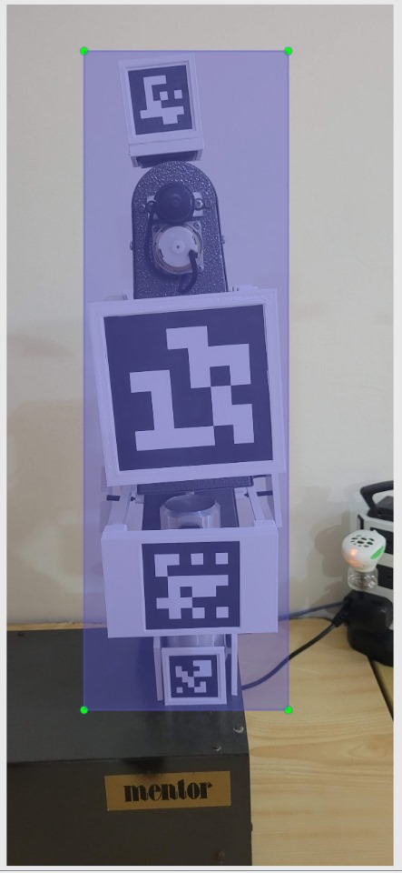

Figure 12: LabelImg software to track the required pixels.

### Dataset Split:

After carefully annotating the dataset, it was systematically divided into separate subsets for training, validation, and testing. This division was crucial for providing distinct datasets for the training, fine-tuning, and evaluation of the machine learning model. A custom script automated this partitioning process, randomly distributing the data according to a predetermined ratio: 70% for training and 30% for testing. This ensured a thorough and unbiased evaluation of the model's performance.

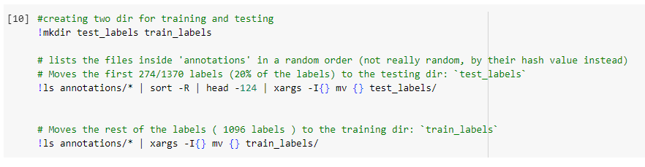

Figure 13: Randomizing the data split to be utilized for training and testing.

### Generate CSV Files:

To systematically organize and manage the annotated data, a structured approach was implemented using CSV (Comma-Separated Values) files. These CSV files contained crucial information, including image file names, associated annotations, and relevant metadata. This method of data organization streamlined the data preparation process, providing efficient and organized access to the necessary information during the development of the machine learning model.

### Generate TF Records:

To ensure compatibility and optimize the dataset for TensorFlow, the data was converted into the TF Records format. This binary file format is designed for the efficient training of deep learning models, improving the data loading process. Converting the dataset to TF Records speeds up data retrieval and integrates seamlessly with TensorFlow, enhancing the overall efficiency and effectiveness of the deep learning model training pipeline.

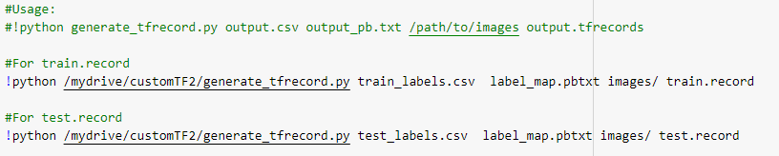

Figure 14: Utilizing a Python script to generate TF records.

### Transfer Learning:

To speed up model development, transfer learning was employed, using a pre-trained neural network as the foundation. This strategy leverages the knowledge gained from models trained on large datasets and adapts it to meet the specific needs of the task. The ssd_mobilenet_v2_fpnlite_320x320_coco17_tpu-8 model was selected as the base architecture, with custom adjustments made to its configuration to align with the project's goals. This use of transfer learning significantly streamlined the development process, enhancing performance by applying insights from broader datasets to the specific task.

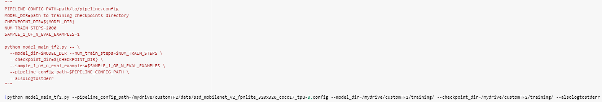

Figure 15: Transfer learning parameters set for the training.

### Training:

With the dataset and model architecture carefully prepared, the training phase began. This crucial stage involved systematically providing training data to the model, fine-tuning its parameters, and conducting multiple epochs to refine and optimize its performance.

### Model Evaluation & Export:

After the training phase, the model's performance was thoroughly evaluated using the validation dataset as a benchmark. This evaluation assessed key metrics such as accuracy, precision, and recall to determine the model's effectiveness for the intended task. Once a satisfactory performance level was achieved, the trained model was carefully exported, ready for deployment to make accurate predictions on new, unseen data with precision and reliability.

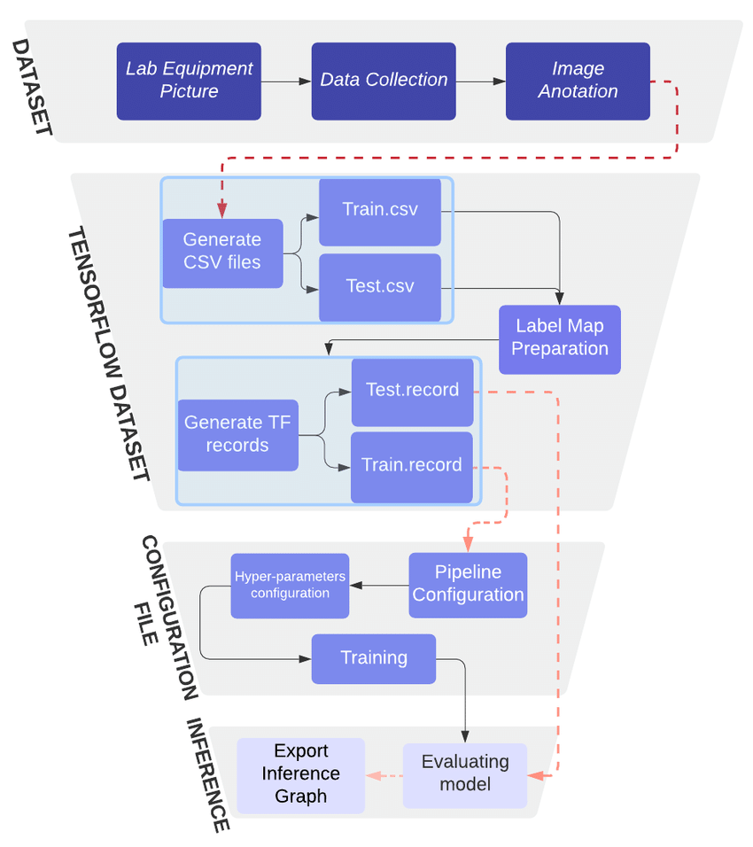

Figure 16: Custom Object Detection Pipeline Example for the forementioned steps [14].

## Marker Selection & Generation

For successful pose estimation, robust fiducial markers are essential. ArUco Markers were chosen for their robustness, accuracy, computational efficiency, and adaptability. Initially, a thorough investigation was conducted to determine the best matrix size for these markers, as shown in Figure 17. The study explored four marker matrix dictionaries: 4x4, 5x5, 6x6, and 7x7. After careful experimentation and evaluation of the project's specific needs, the 6x6 dictionary was selected.

A custom script was developed to generate these markers systematically, ensuring precise dimensions, unique identification codes, and compliance with the selected dictionaries. This script is flexible, allowing for customization and the creation of markers suited to different applications and environmental conditions. This approach, supported by rigorous testing and optimization, highlights the system's robustness and adaptability, proving its effectiveness in various real-world scenarios.

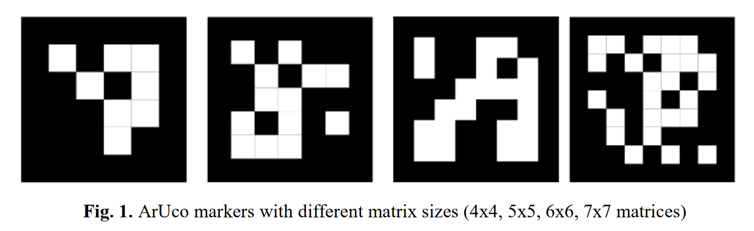

Figure 17: ArUco Markers with different matrix size [15].

## Marker Placement and Design

In the initial design phase, a strategic plan was implemented to place markers on all four sides (front, back, left, and right) of the robotic arm. This configuration was carefully chosen to enable comprehensive positional tracking and ensure clear orientation visibility from any perspective.  
  
The markers were designed to integrate seamlessly with the robotic arm's joints, considering the shape, size, and mechanical constraints of the arm. Figure 18 shows the CAD blueprint created to accommodate the markers on the end effector. The successful integration of these markers onto the robotic arm's structure is illustrated in Figure 19.

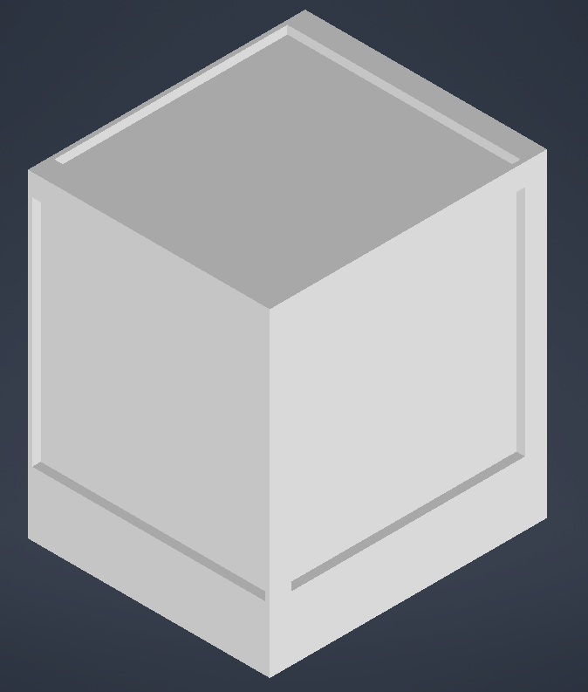

Figure 18: CAD model of end-effector marker placement.

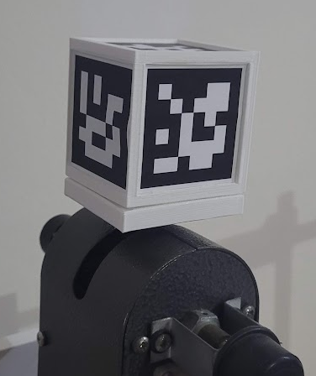

Figure 19: Design implemented on end-effector.

## Camera Calibration

Camera calibration is crucial for pose estimation as it corrects lens distortion and estimates perspective geometry. The ChArUco board calibration method was chosen for its efficiency and robustness, combining the benefits of ArUco markers with a checkerboard pattern. To facilitate this method, a custom script was created to generate the necessary ChArUco board configurations with precise parameters. This involved calibrating the marker and board dimensions to maintain the correct relative size ratio, as calibration accuracy depends on this proportion. The parameterization included determining the number of squares, square dimensions, marker size, ArUco matrix specifications, and dictionary selection.

The calibration process produced two ChArUco boards: one with A1 dimensions and another with A3 dimensions, shown in Figures 20 and 21. These boards are essential for achieving precise and distortion-free camera calibration, ensuring accurate pose estimation for the system.

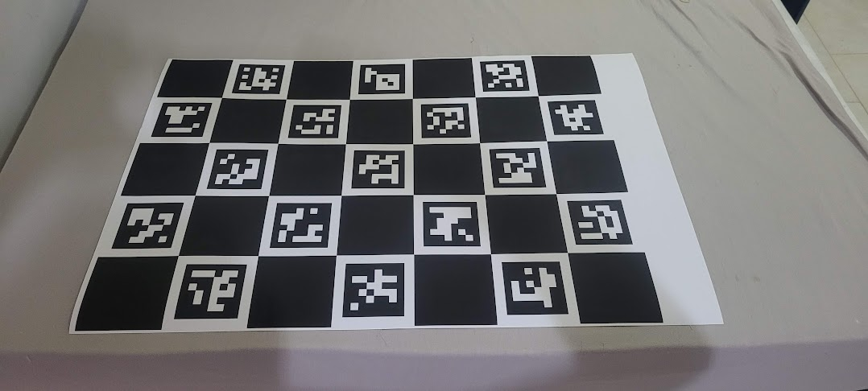

Figure 20: A1 ChArUco Board (5x7)

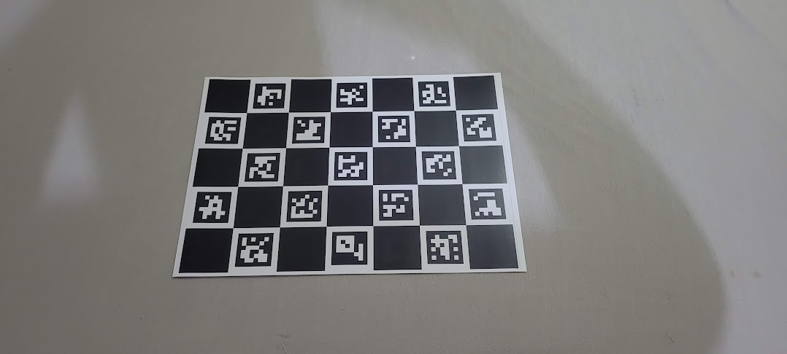

Figure 21: A3 ChArUco Board (5x7)

Numerous photos of the ChArUco boards were systematically taken using the client's camera, capturing various angles, orientations, and positions to ensure the boards consistently stayed within the frame. These diverse images were then processed using a custom script designed to precisely calculate the camera matrix and distortion coefficients. Figure 22 below illustrates this computational outcome. These accurately derived camera parameters are crucial for precise image rectification and form a foundational element in the subsequent phases of the pose estimation pipeline.

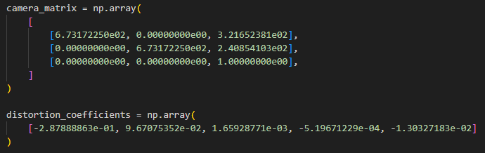

Figure 22: Camera matrix and distortion coefficients.

### ArUco Marker Data Extraction

After completing the camera calibration, a dedicated script was deployed to extract rotational and translational matrices from the ArUco markers. This script operates in real-time, processing the live camera feed, detecting and decoding the markers, and computing the necessary rotational and translational matrices. These calculations are based on the camera's perspective, which serves as the reference frame. The camera matrix and distortion coefficients are crucial in this process, enabling corrections specific to the camera used. Figure 23 below illustrates this dynamic process and displays the calculated rotational matrices.

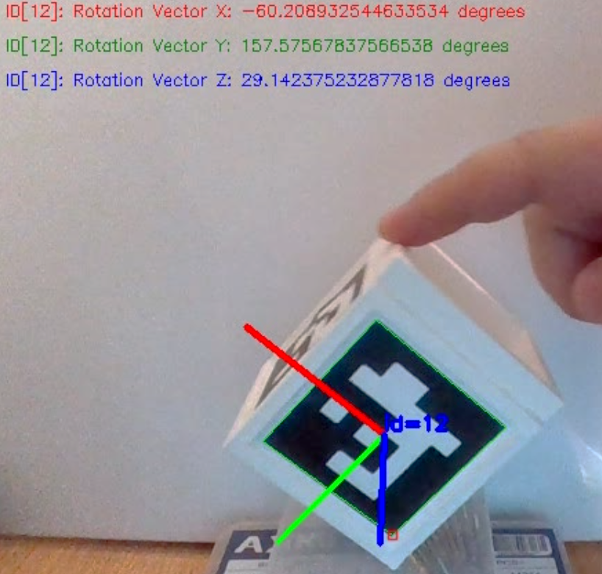

Figure 23: Extracted pose angles.

## CAD Augmentation

Certain adjustments were necessary to address the specific design constraints of the robotic system. Specifically, a dedicated shaft and mechanical component were created, as shown in Figures 24 and 25. The main goal was to ensure that the markers would move in parallel when attached.

Using CAD software, we precisely defined the specifications, dimensions, and tolerances for the shaft. This careful engineering effort focused on ensuring the synchronized movement of the markers. This approach guarantees the optimal functionality of the robotic system and reduces the potential for errors or misalignments. The integration of CAD tools and robotic systems in these designs highlights the importance of detailed engineering in achieving precise robotic motion and overall functionality.

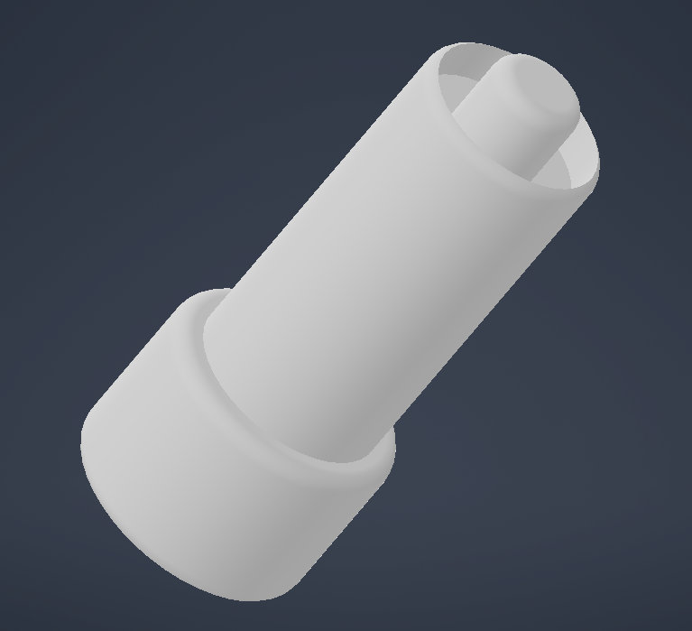

Figure 24: 3D Printed Augmenting Shaft

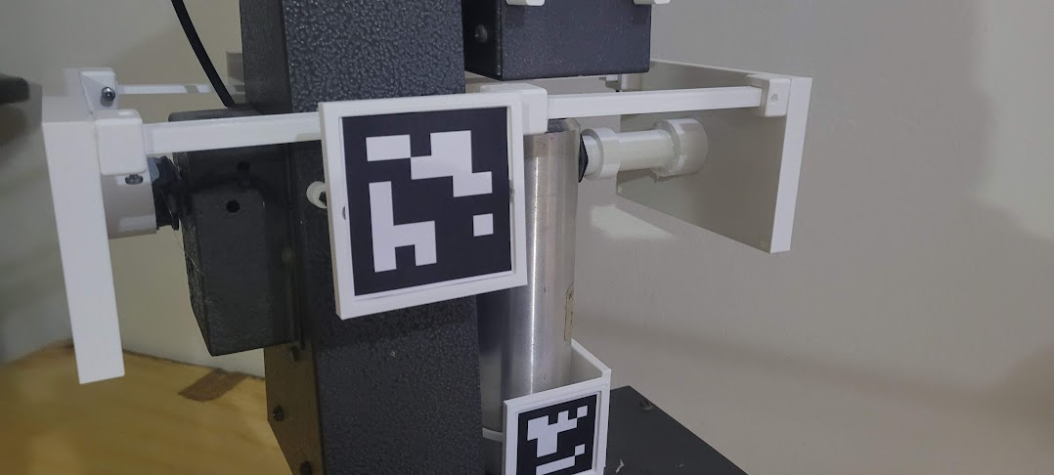

Figure 25 Augmentation on the Robotic System

## Live Virtual Prototype using DH Parameters in MATLAB

The creation of this Live Virtual Prototype using Denavit-Hartenberg (DH) parameters in MATLAB aims to establish an interactive simulation environment for a robot arm. The software framework initiates a TCP/IP connection on the localhost to receive real-time data, including various joint angles relevant to the robot's configuration.

Once the data is received, the software parses the incoming string to extract key information about the positions of the robot's components, including the base, shoulder, elbow, end effector, and the pitch of the end effector. This data is then used to dynamically plot and visualize the robot's current configuration in real-time, providing a live representation of its movements.

The structural and kinematic attributes of the robot are defined using DH parameters, which efficiently describe the robot's geometric and joint configurations. This approach facilitates the rapid simulation and visualization of complex robotic systems.

If parsing errors occur, the robot maintains its default position to ensure the safety and stability of the simulation environment. Overall, this live virtual prototype is an invaluable tool for testing, visualization, and understanding the robot's motion and behaviour, offering critical insights before real-world implementation.

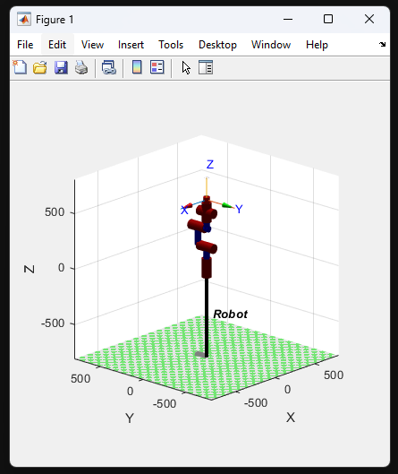

Figure 26 Live Virtual Prototype

## Block Diagram of The Overall System

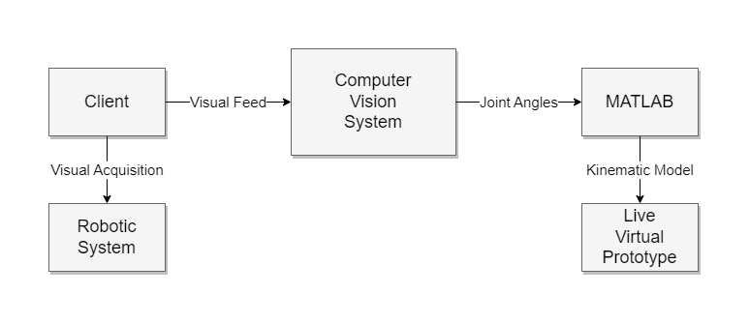

Figure 27: Block Diagram of The Overall System

## Flowcharts

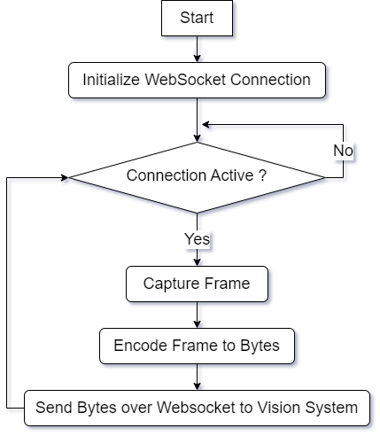

Figure 28: Client System Flowchart

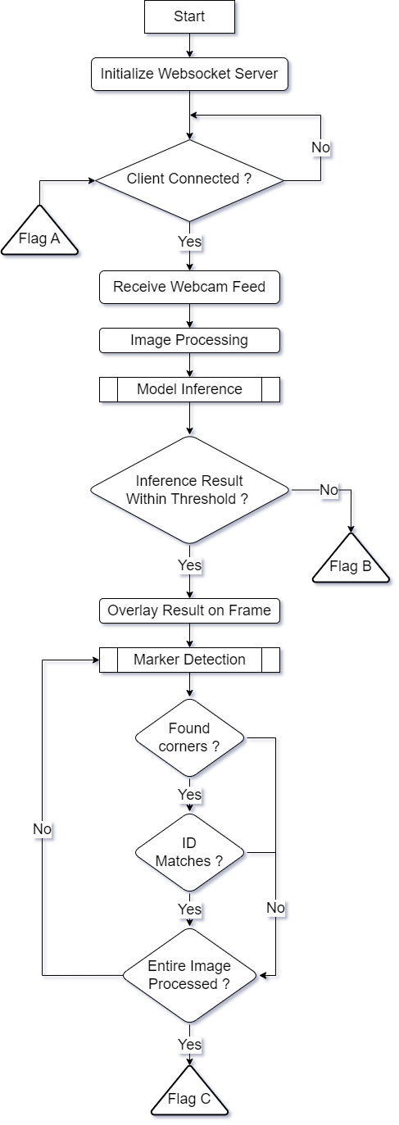

Figure 29: Vision System Flowchart Part 1

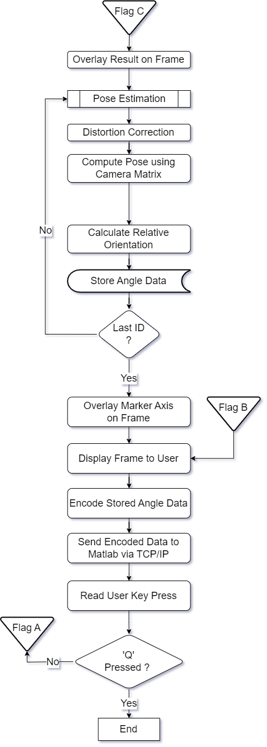

Figure 30: Vision System Flowchart Part 2

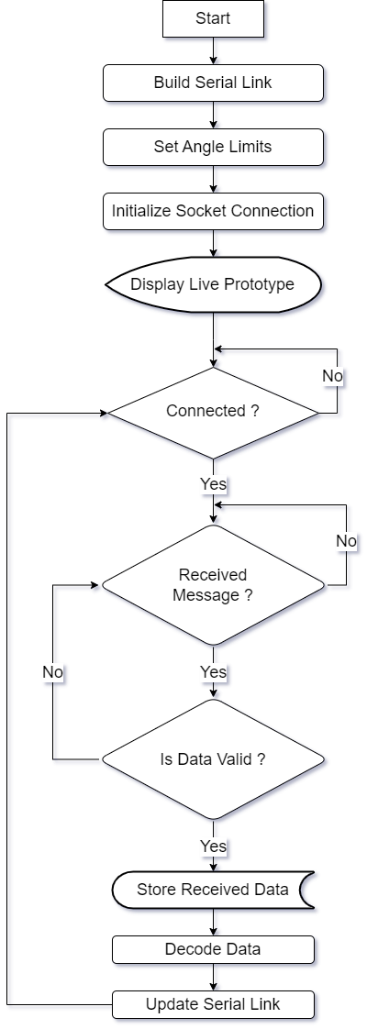

Figure 31: MATLAB System Flowchart

# ****Analysis of Results and Discussion****

## Initial Testing

During this study, numerous tests were conducted to evaluate the TensorFlow-based tracking system, focusing on TensorFlow Lite. The main goal was to determine the model's practical viability across various hardware environments.

Initially, high-end Raspberry Pi systems were used as the testbed, with TensorFlow Lite chosen for its low resource requirements, making it suitable for devices with limited computational power. However, the results were unsatisfactory. Despite the Raspberry Pi being a powerful model in its category, it struggled to meet performance standards. TensorFlow Lite, while optimized for less powerful devices, could not handle the demands of this environment.

Recognizing these limitations, a shift in approach was necessary. It was hypothesized that a Windows-based workstation with superior processing capabilities could handle the required computational tasks more effectively. To test this, a pipeline was created to transmit the client's webcam feed directly to the Windows workstation for processing.

The results confirmed the hypothesis, showing a significant performance improvement with the Windows workstation compared to the Raspberry Pi. However, this new approach introduced challenges related to network constraints.

When the system was deployed in a hotspot environment, there was noticeable performance degradation due to network instability, affecting the speed and reliability needed for intensive tasks. Despite this, the Windows workstation still outperformed the Raspberry Pi setup, indicating progress in system performance and feasibility in diverse environments.

## Tracking Testing

In the comprehensive testing phase dedicated to tracking the robotic system, a series of meticulously designed experiments were conducted across diverse environmental settings. These experiments sought to evaluate the model's performance under varying conditions, including scenarios marked by occlusions and differing distances between the observer and the robot.

### Tracking ArUco markers

A script was implemented to facilitate controlled rotations of the cube, which featured ArUco markers affixed to its surfaces. This script served the purpose of systematically observing the tracking performance along all axes during the cube's motion. Notably, the script was designed to accommodate the detection of multiple markers concurrently.

The results, as depicted in *Figures 32 - 34*, demonstrate the model's ability to successfully detect multiple markers from varying angles. These findings emphasize the model's competence and adaptability in addressing diverse tracking scenarios.

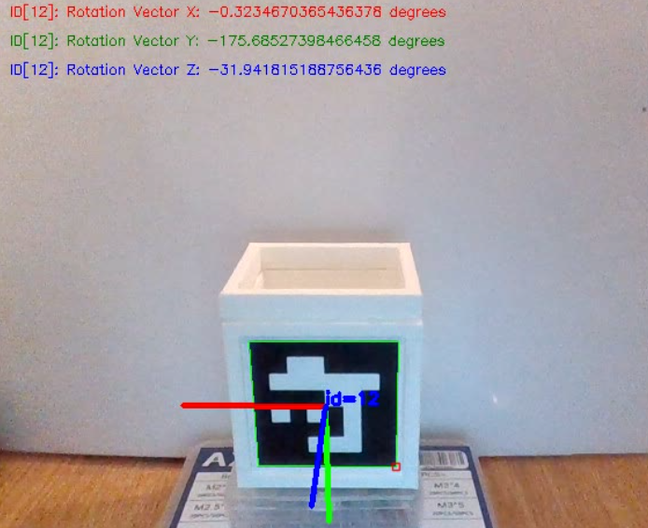

Figure 32: ArUco marker Vector X set at 0°.

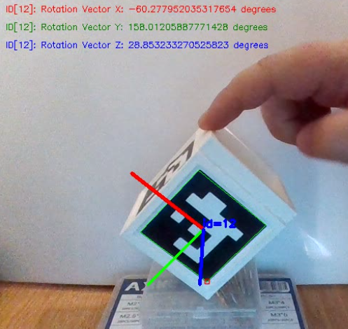

Figure 33: ArUco marker Vector X set at 60°.

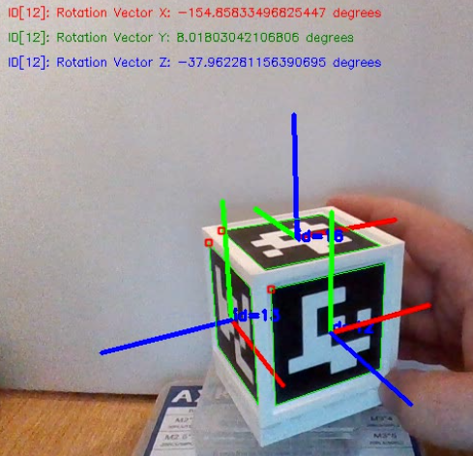

Figure 34: Detection of multiple ArUco markers with change in all Vectors.

### Tracking of Robotic Arm

The main focus was to assess the model's reliability in accurately tracking the robot's movements and pose, even when faced with challenging environmental factors. This testing involved tracking the robotic arm and with an obstruction, simulating real scenarios. This could be observed in *Figures 35 & 36*.

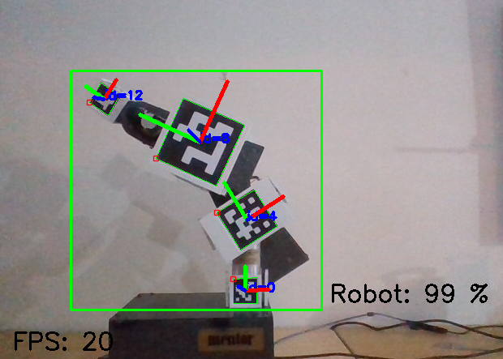

Figure 35: Tracking the robotic arm unobstructed.

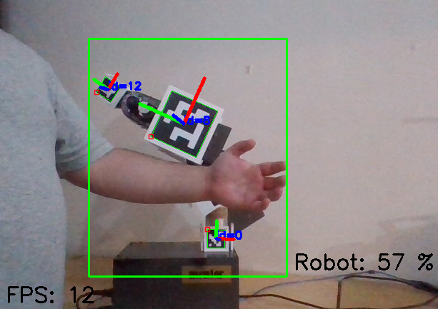

Figure 36: Tracking robotic arm obstructed.

The results unveiled a consistently impressive performance, with the model maintaining a reliability rate exceeding 80% across the majority of the trials for the unobstructed.

However, a noteworthy observation emerged when the robot ventured into regions where its visibility to the tracking system was compromised due to occlusions. In such instances, the model's performance exhibited a discernible decline, resulting in a reduction in the reliability percentage. This phenomenon was anticipated, as occlusions inherently obstruct the model's ability to maintain continuous tracking.

Notably, as the distance between the observer and the robot increased, further tests unveiled a reduction in tracking reliability. This phenomenon can be attributed to the inherent challenges posed by greater distances, which can diminish the quality and clarity of the visual data available to the tracking system.

### Analysis of tracking model

Through careful monitoring of the model's performance on *TensorBoard*, a collection of informative plots has been compiled. These plots provide a comprehensive view of the machine learning process, showcasing key metrics such as classification loss, localization loss, regularization loss, and the total loss, which combines these components.

These visual representations utilize a standard Cartesian coordinate system, where the x-axis tracks the progress of epochs, and the y-axis displays the loss values. *Figure 37*, presented below, offers a visual summary of this data.

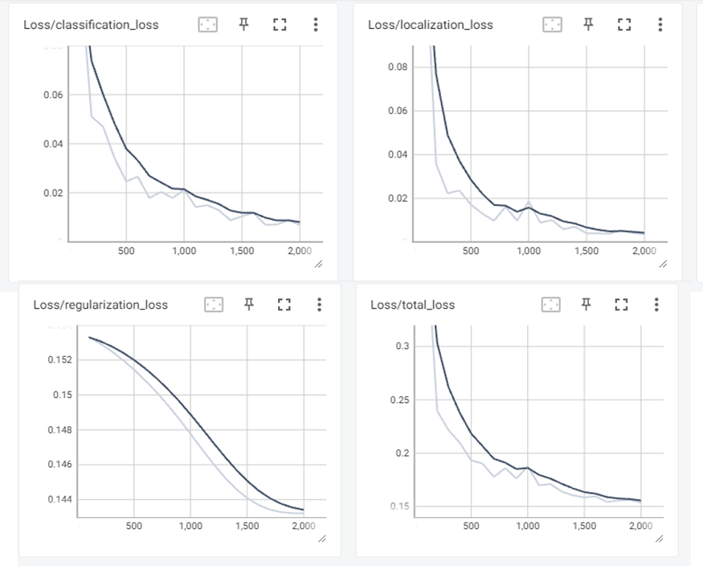

Figure 37: Loss of machine learning model over epochs.

Within this graphical depiction, bright lines represent machine learning loss, while darker lines denote validation losses. A thorough analysis of these results highlights the model's strong performance. The close alignment between validation loss and training loss underscores the model's ability to effectively recognize and learn general patterns, enabling it to make accurate predictions on previously unseen data.

## Pose Estimation

In the domain of Pose Estimation, the objective is to harmonize the previous testing procedures to achieve precise tracking of the robotic system's spatial coordinates and joint angles. The upcoming *Figures 38 & 39* visually depict the outcomes of both the tracking of the robotic arm and the angle of the joints.

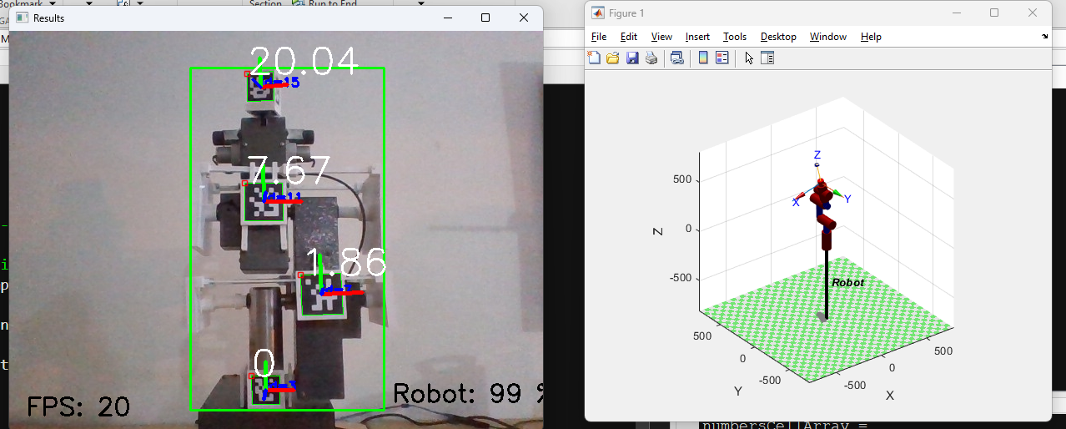

Figure 38: Robot tracking and angle tracking of joints from one side.

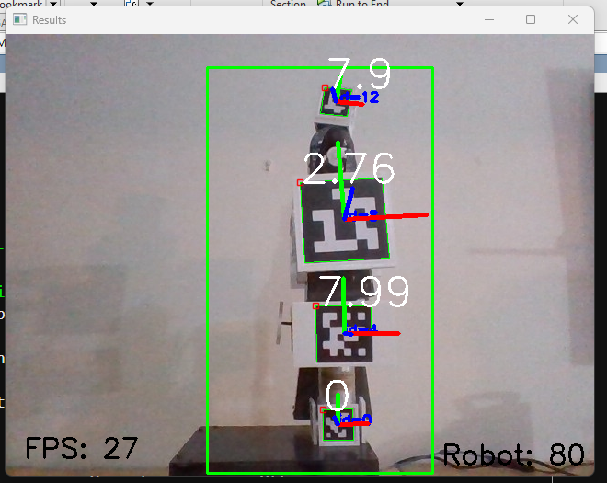

Figure 39: Robot tracking and angle tracking of joints from another side.

### Testing Accuracy

In pursuit of precise accuracy assessment for pose estimation, a specialized testing apparatus was meticulously crafted through CAD techniques. The deployment of 3D printing technology played a pivotal role in the construction of this testing apparatus, ensuring precision and repeatability in its design and manufacture.

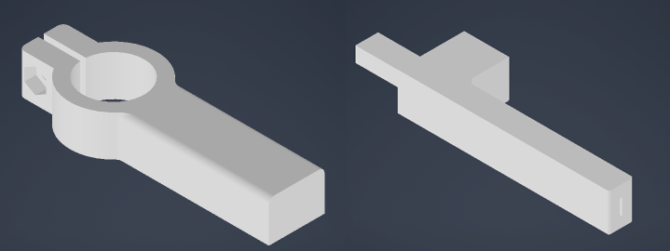

Figure 40: 3D prints used to make the testing apparatus.

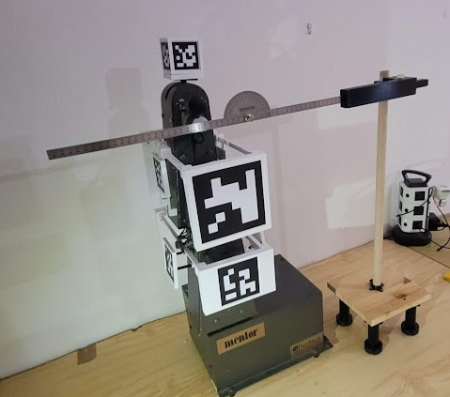

Figure 41: Robotic arm with test setup.

During the testing phase, meticulous attention was given to maintaining optimal levels of precision. To achieve this, a spirit bubble was employed to meticulously level all components of the testing apparatus. This approach was instrumental in ensuring that any discrepancies in measurements were not attributed to misalignment or uneven surfaces but were instead a true reflection of the system's performance.

The primary objective of the testing apparatus was to validate the accuracy of the measured angles. This validation extended beyond a mere comparison with the inputted angles into the robot, as it acknowledged the potential for inherent imprecisions stemming from potentiometer limitations. To establish a robust benchmark for accuracy assessment, a professional-grade protractor was integrated into the testing apparatus.

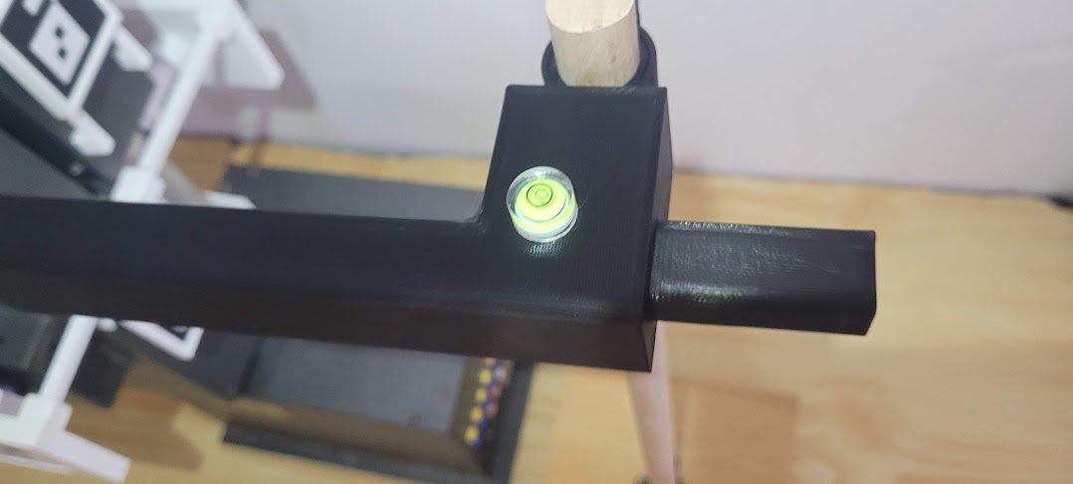

Figure 42: Application of spirit bubble to keep test setup level.

To further enhance the precision of the apparatus, adjustable feet were incorporated. These adjustable feet provided a means to fine-tune and maintain the protractor's level, ensuring the highest degree of accuracy during testing procedures.

One of the key functionalities of this testing setup was the ability to discern and record the angle of movement of the marker with remarkable precision. This process facilitated a comprehensive evaluation of the system's pose estimation accuracy, delivering insights into its real-world performance in a controlled and highly accurate testing environment.

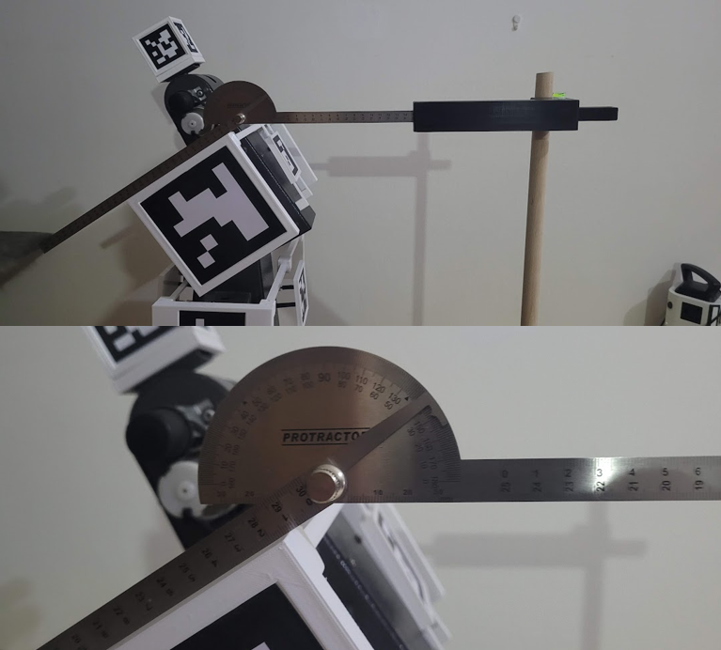

Figure 43: Reading the angle of movement of the elbow marker.

By aggregating the dataset within Microsoft Excel and creating visual plots that put together the sensor angle, protractor-derived angle, and encoder-inputted angle, a lucid depiction of the system's accuracy emerges. The following plots, presented below, provide a concise and coherent portrayal of the interrelationships between these critical variables.

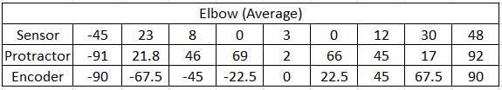

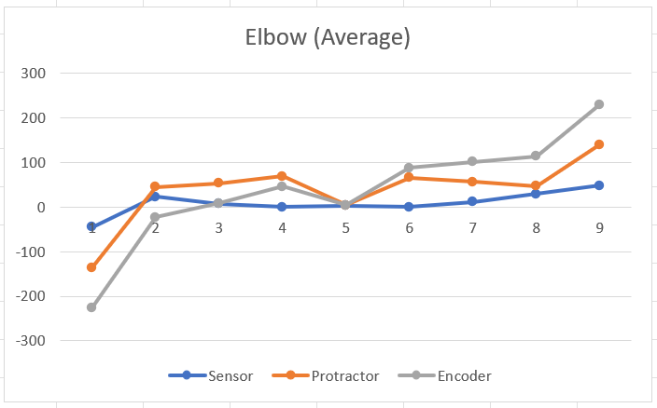

Figure 44: Elbow average from multiple tests.

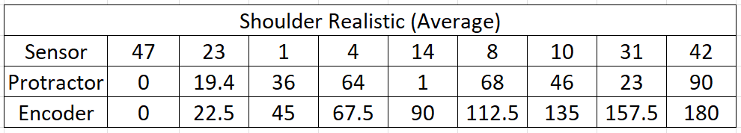

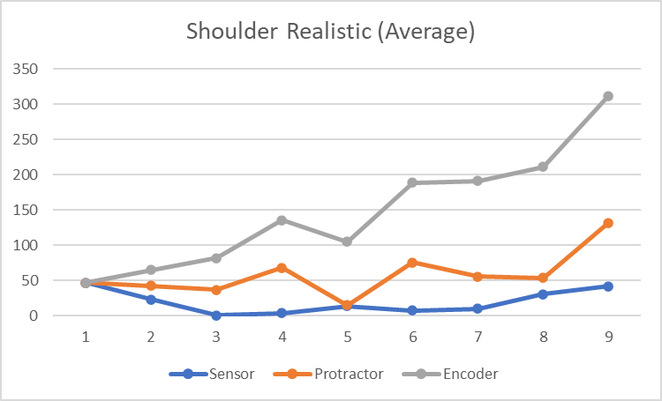

Figure 45: Shoulder average from multiple tests.

As could be noted from the graphs above both the elbow and shoulder show a relationship between the sensor angle, the protractor-derived angle and from the encoder-inputted angle.

## Final Result

By integrating pose estimation, tracking, and the live virtual prototype, a refined outcome will showcase the actual robotic arm with concurrent real-time angle data and a dynamic representation of the arm within the MATLAB environment. These integrated results are visually presented in *Figure 46*.

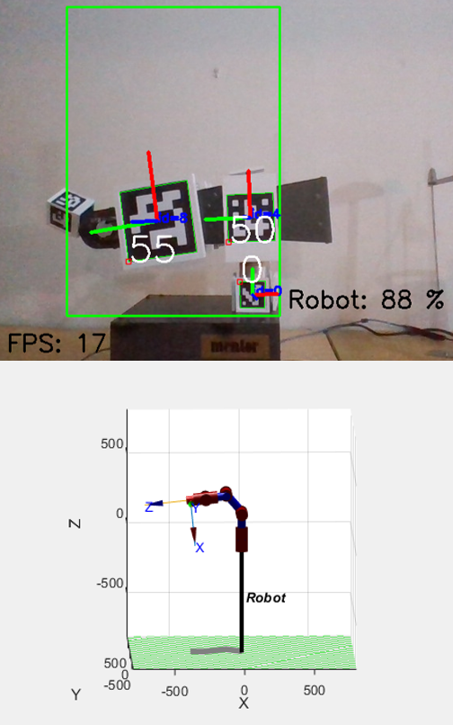

Figure 46: Pose estimation and tracking followed with real-time representation on MATLAB.

# Conclusions and Recommendations

## Overview

This research journey has been characterized by an unwavering commitment to the refinement and advancement of robotic pose estimation and tracking. It initially set out with the aspiration of utilizing a single-board computer, typified by the Raspberry Pi, as the foundational element of the computer vision system. The objective was to leverage these compact and versatile devices for real-time object tracking and joint angle estimation within the robotic arm. However, the research path was riddled with challenges, revealing formidable limitations in this approach.

The first significant obstacle encountered was the restricted frame rate (fps) of the Raspberry Pi, which severely hindered the system's capacity to swiftly capture and process images. In the realm of real-time tracking, where every millisecond counts, a suboptimal frame rate inevitably leads to imprecise tracking and diminished system performance. Additionally, the demanding computational requirements imposed by advanced object tracking and pose estimation algorithms strained the Raspberry Pi's processing capabilities, resulting in operational inefficiencies.

Faced with these formidable challenges, the research trajectory underwent a transformative shift, departing from reliance on the Raspberry Pi to embrace a more robust and powerful computing platform. The research pivoted toward a Windows-based machine, fortified with TensorFlow and dedicated accelerator cards. This transition marked a critical turning point, mitigating the constraints of frame rate and processing power while opening up new frontiers for advanced machine learning and computer vision techniques.

## Achievements

In the relentless pursuit of enhancing the capabilities of the robotic system, this research has marked several significant milestones. Foremost among these accomplishments is the precise detection and measurement of joint angles within the robotic arm. This achievement was made possible through the utilization of ArUco markers, distinguished by their distinctive visual patterns that facilitate identification and tracking. ArUco markers emerged as invaluable assets, endowing the system not only with the capacity to recognize the presence of the robotic arm but also with the precision to discern the angles of its individual joints accurately. This breakthrough empowers robots with the ability to comprehensively comprehend their spatial orientation and position within their environment—an advancement with profound implications across a spectrum of applications, from industrial automation to healthcare.

Another notable milestone resides in the domain of object tracking, with a particular emphasis on tracking the robotic arm itself. The research demonstrated exceptional accuracy in tracking the arm's movements, even in the face of challenging environmental factors. Occlusions, varying distances, and complex backgrounds posed formidable challenges, yet the system consistently exhibited its prowess in maintaining accurate tracking. This achievement amplifies the robotic arm's situational awareness and enhances its capacity to interact with objects and navigate intricate, dynamic environments.

## Improvements

While the accomplishments are commendable, the research findings have also unveiled areas primed for further refinement and exploration. Prominent among these areas is the occurrence of false positives in angle detection. To address this challenge effectively, a multifaceted approach can be contemplated.

Improving lighting conditions is crucial to reduce false positives. By optimizing lighting, markers can remain highly visible and easily distinguishable. Thoughtful placement of lighting sources and the use of advanced illumination techniques can significantly enhance marker detection accuracy.

Expanding and diversifying the dataset employed for model training presents an avenue to fortify angle detection. A more comprehensive dataset, spanning diverse scenarios and conditions, can bolster the model's robustness and capacity to discern positive and negative angles with heightened precision.

Exploring different ArUco marker sizes and configurations can be beneficial. Testing various marker sizes and arrangements can provide insights into the optimal configuration for improved detection accuracy.

The exploration of advanced image processing techniques holds the promise of further refining angle detection and curtailing false positives. Techniques such as noise reduction, feature enhancement, and advanced filtering algorithms can be leveraged to elevate the quality of image data, facilitating more accurate angle estimation.

Furthermore, the research should focus on further optimizing the network and data transfer pipelines to reduce the impact of network instability on the overall system performance. This optimization would potentially make the system more robust even in hotspot-based or otherwise constrained network conditions.

Finally, the optimization of camera capabilities is pivotal. The research can delve into the adoption of high-quality cameras characterized by enhanced resolution and heightened sensitivity to markers. Advanced camera models, equipped with state-of-the-art sensors, can augment marker detection, even in demanding conditions such as low-light environments or situations featuring rapidly changing distances.

In conclusion, despite the myriad areas for potential improvements identified throughout this research, it is imperative to underscore that the implemented system fulfils its initial objective. While acknowledging the considerable scope for further refinement and optimization, the system's showcased proficiency in robotic pose estimation and tracking, alongside its commendable accuracy, firmly establish its suitability for practical real-world applications. This research serves as a cornerstone for prospective advancements in the domains of robotics and computer vision, offering the prospect of enhanced precision and a brighter future for human-robot interaction and automation.

# References

|  |  |
| --- | --- |
| [1] | G. M. H. N. H. Ali, “Kalman Filter Tracking,” *International Journal of Computer Applications,* 2014. |
| [2] | M. P. a. A. Calway, “Real-Time Camera Tracking Using a Particle Filter,” University of Bristol, UK, 2005. |
| [3] | J. G. M. S. M. C. D. P. F. H. J. C. M. Marrón, Comparing a Kalman Filter and a Particle Filter in a Multiple Objects Tracking Application. |
| [4] | L. Tan, Comparison of RetinaNet, SSD, and YOLO v3 for real-time pill identification, 2021. |
| [5] | Á. S. A. B. M. Á. D. S. J. F. V. Ángel Morera, SSD vs. YOLO for Detection of Outdoor Urban Advertising Panels under Multiple Variabilities, 2020. |
| [6] | S. L. ,.-W. S. Y. W.-S. C. a. S.-J. K. Gwon Hwan An, “Charuco Board-Based Omnidirectional Camera Calibration Method,” 2018. |
| [7] | R. S. S. &. M. S. Reilink, “3D position estimation of flexible instruments: marker-less and marker-based methods,” 2012. |
| [8] | S. C. A. A. C. W. N. V. Michail Kalaitzakis, Experimental Comparison of Fiducial Markers for Pose Estimation, 2020. |
| [9] | S. K. a. Z. Bingul, Robot Kinematics: Forward and Inverse Kinematics, 2006. |
| [10] | H. W. L. L. J. .. I. ,. e. a. Hadfield, “The Forward and Inverse Kinematics of a Delta Robot.,” 2020. |
| [11] | A. A. S. Kaushal Dholariya, Conceptual Design and Kinematic Analysis of Humanoid Robot, 2016. |
| [12] | V. S. a. A. T. M. Noman, “Object Detection Techniques: Overview and Performance Comparison,” Ajman, 2019. |
| [13] | J. M. a. S. B. R. Phadnis, “Objects Talk - Object Detection and Pattern Tracking Using TensorFlow,” Coimbatore, 2018. |
| [14] | S. P. X. Y. a. Q. N. John Estrada, Deep-Learning-Incorporated Augmented Reality Application for Engineering Lab Training, 2022. |
| [15] | B. T. Zoltan Siki, Automatic Recognition of ArUco Codes in Land Surveying Tasks, 2021. |
| [16] | P. I. Corke, “A Simple and Systematic Approach to Assigning Denavit–Hartenberg Parameters,” 2007. |
| [17] | A. S. S. S. Amanpreet Singh, D-H Parameters Augmented with Dummy Frames for Serial Manipulators Containing Spatial Links, 2014. |
| [18] | O. G. Anton Larsson, Comparative Analysis of the Inverse Kinematics of a 6-DOF Manipulator, 2023. |

# Appendix A Marker Generation Script

import numpy as np

import cv2

import os

import cv2.aruco as aruco

def generate_aruco_marker(marker_id, markerSize, marker_size_cm, resolution_ppcm, image_path):

    # Calculate the marker size in pixels at the specified resolution

    marker_size_pixels_res = int(marker_size_cm * resolution_ppcm)

    # Create a dictionary with the desired ArUco marker parameters

    key = getattr(cv2.aruco,f'DICT_{markerSize}X{markerSize}_1000')

    aruco_dict = aruco.getPredefinedDictionary(key)

    # Create an image with the ArUco marker

    marker_image = aruco.drawMarker(aruco_dict, marker_id, marker_size_pixels_res)

    # Save the marker image to a file

    cv2.imwrite(image_path, marker_image)

def generate_white_box(box_size_cm, resolution_ppcm, output_path):

    # Calculate the box size in pixels

    box_size_pixels = int(box_size_cm * resolution_ppcm)

    # Create a white box image

    box_image = np.ones((box_size_pixels, box_size_pixels), dtype=np.uint8) * 255

    # Save the white box image to a file

    cv2.imwrite(output_path, box_image)

    print("White box generation complete!")

# White box generation settings

box_size_cm = 5.4

white_res_ppcm = 37.84

output_path = "3_Markers Design/white_box.png"

# Marker generation settings

markerSizeStart = 6

markerSizeEnd = 6

num_markers = 20

marker_size_cm = 5

marker_res_ppcm = 37.8

# Generate white box

generate_white_box(box_size_cm, white_res_ppcm, output_path)

# Generate markers

os.makedirs("3_Markers Design/Generated_Markers", exist_ok=True)

for i in range(markerSizeEnd+1):

    if i >= markerSizeStart:

        for j in range(num_markers):

            marker_id = j

            marker_path = f"3_Markers Design/Generated_Markers/{i}x{i}_marker_{j}.png"

            generate_aruco_marker(marker_id, i, marker_size_cm, marker_res_ppcm, marker_path)

            print(f"Generated {i}x{i}_marker_{j}")

# Generate box markers

os.makedirs("3_Markers Design/Generated_Box_Markers", exist_ok=True)

for i in range(markerSizeEnd+1):

    if i >= markerSizeStart:

        for j in range(num_markers):

            # Load the images

            background = cv2.imread("3_Markers Design/white_box.png")

            marker_path = f"3_Markers Design/Generated_Markers/{i}x{i}_marker_{j}.png"

            overlay = cv2.imread(marker_path)

            # Extract the dimensions of the image

            height_b, width_b, channels_b = background.shape

            height_o, width_o, channels_o = overlay.shape

            # ROI Algorithm

            y , x = tuple((background.shape[i] - overlay.shape[i]) // 2 for i in range(2))

            h , w = overlay.shape[:2]

            # Create a mask

            mask = np.zeros(background.shape[:2], dtype=np.uint8)

            mask[y:y+h, x:x+w] = 255

            # Loop over each pixel in the background image and update based on the mask

            for k in range(background.shape[0]):

                for v in range(background.shape[1]):

                    if mask[k, v] != 0:

                        background[k, v] = overlay[k-y, v-x]

            # Save the modified image

            box_marker_path = f"3_Markers Design/Generated_Box_Markers/{i}x{i}_marker_{j}.png"

            cv2.imwrite(box_marker_path, background)

            print(f"Generated {i}x{i}_box_marker_{j}")

# Appendix B – Camera Calibration Script

import cv2

import numpy as np

# Define the size of the Charuco board (in squares)

squaresX = 8

squaresY = 6

squareLength = 0.04  # length of each square (in meters)

markerLength = 0.02  # length of each marker (in meters)

# Create the Charuco board

board = cv2.aruco.CharucoBoard_create(squaresX, squaresY, squareLength, markerLength, cv2.aruco.getPredefinedDictionary(cv2.aruco.DICT_6X6_250))

# Capture images of the Charuco board

img_paths = ['image1.png', 'image2.png', 'image3.png', ...]  # list of image paths

objpoints = []  # list of object points

imgpoints = []  # list of image points

for img_path in img_paths:

    # Load the image

    img = cv2.imread(img_path)

    # Convert the image to grayscale

    gray = cv2.cvtColor(img, cv2.COLOR_BGR2GRAY)

    # Detect the markers of the Charuco board in the image

    corners, ids, rejectedImgPoints = cv2.aruco.detectMarkers(gray, cv2.aruco.getPredefinedDictionary(cv2.aruco.DICT_6X6_250))

    charuco_corners, charuco_ids, _ = cv2.aruco.interpolateCornersCharuco(corners, ids, gray, board)

    # Collect the object points and image points

    if len(charuco_corners) > 0:

        objpoints.append(board.objPoints)

        imgpoints.append(charuco_corners)

# Calibrate the camera

ret, mtx, dist, rvecs, tvecs = cv2.calibrateCamera(objpoints, imgpoints, gray.shape[::-1], None, None)

# Save the camera matrix and distortion coefficients to a file

np.savetxt('camera_matrix.txt', mtx)

np.savetxt('distortion_coefficients.txt', dist)

**Appendix C – Client Webcam Feed Script**

import asyncio

import cv2

import numpy as np

import time

import websockets

async def receive_frames():

    async with websockets.connect('ws://100.77.189.76:8765') as websocket:

        cap = cv2.VideoCapture(0)

        start_time = time.time()

        frames = 0

        while True:

            # Receive the frame from the websocket

            data = await websocket.recv()

            # Convert the bytes to a NumPy array

            buffer = np.frombuffer(data, dtype=np.uint8)

            # Decode the JPEG image

            frame = cv2.imdecode(buffer, cv2.IMREAD_COLOR)

            # Calculate the elapsed time and FPS

            elapsed_time = time.time() - start_time

            fps = frames / elapsed_time

            # Display the FPS counter on the image

            fps_text = f"FPS: {fps:.2f}"

            cv2.putText(frame, fps_text, (10, 30), cv2.FONT_HERSHEY_SIMPLEX, 1, (0, 255, 0), 2)

            # Show the image

            cv2.imshow('Frame', frame)

            # Close all windows when q pressed

            if cv2.waitKey(1) & 0xFF == ord('q'):

                break

            # Increment the frame counter

            frames += 1

        cv2.destroyAllWindows()

# Start the client to receive frames

asyncio.get_event_loop().run_until_complete(receive_frames())

# Appendix D – Server Webcam Feed Script

import asyncio

import cv2

import numpy as np

import websockets

async def video_feed(websocket, path):

    cap = cv2.VideoCapture(0)

    while True:

        ret, frame = cap.read()

        if not ret:

            break

        # Convert the frame to bytes

        _, buffer = cv2.imencode('.jpg', frame)

        data = buffer.tobytes()

        # Send the frame over the websocket

        await websocket.send(data)

        print("working")

    cap.release()

# Start the websocket server

start_server = websockets.serve(video_feed, '100.77.189.76', 8765) #hp

#start_server = websockets.serve(video_feed, '100.89.155.88', 8765) #epyc

asyncio.get_event_loop().run_until_complete(start_server)

asyncio.get_event_loop().run_forever()

**Appendix E – Dataset Pipeline & Training Script**

import os

import glob

import xml.etree.ElementTree as ET

import pandas as pd

import zipfile

import shutil

import random

# Step 1: ADD images.zip and annotations.zip to customTF2

# Step 2: Enter Virtual Enviroemnt name

# Step 3: Enter the path for the python vm with tensorflow installed in anacondaPath

# Step 4: Run File

#user parameters

virtenv = "test"

anacondaPath  = "D:/anaconda3/envs/" + virtenv + "/python.exe"

def extract():

  path_to_zip_file1 = "customTF2/images.zip"

  path_to_zip_file2 = "customTF2/annotations.zip"

  directory_to_extract_to = "customTF2/data"

  with zipfile.ZipFile(path_to_zip_file1, 'r') as zip_ref:

      zip_ref.extractall(directory_to_extract_to)

  with zipfile.ZipFile(path_to_zip_file2, 'r') as zip_ref:

      zip_ref.extractall(directory_to_extract_to)

def split():

    test_path = "customTF2/data/test_labels"

    train_path = "customTF2/data/train_labels"

    if not os.path.exists(test_path):

        os.mkdir(test_path)

    if not os.path.exists(train_path):

        os.mkdir(train_path)

    src_folder = r"customTF2/data/annotations"

    dst_folder1 = r"customTF2/data/test_labels"

    dst_folder2 = r"customTF2/data/train_labels"

    pattern = "\*.xml"

    files = glob.glob(src_folder + pattern)

    totalDataSet = 0

    for path in os.listdir(src_folder):

        if os.path.isfile(os.path.join(src_folder, path)):

            totalDataSet += 1

    randList =  random.sample(range(totalDataSet), totalDataSet)

    i = 0

    for file in files:

        if( i <= (totalDataSet * 0.2)):

            file_name = os.path.basename(files[randList[i]])

            shutil.move(files[randList[i]], dst_folder1 + "/" + file_name)

            print('Moved to test:', files[randList[i]])

        elif(i > (totalDataSet * 0.2)):

            file_name = os.path.basename(files[randList[i]])

            shutil.move(files[randList[i]], dst_folder2 + "/" + file_name)

            print('Moved to train:', files[randList[i]])

        i = i + 1

def xml_to_csv(path): #path -> customTF2/data/

  classes_names = []

  xml_list = []

  for xml_file in glob.glob(path + '/*.xml'):

    tree = ET.parse(xml_file)

    root = tree.getroot()

    for member in root.findall('object'):

      classes_names.append(member[0].text)

      value = (root.find('filename').text  ,

               int(root.find('size')[0].text),

               int(root.find('size')[1].text),

               member[0].text,

               int(member[4][0].text),

               int(member[4][1].text),

               int(member[4][2].text),

               int(member[4][3].text))

      xml_list.append(value)

  column_name = ['filename', 'width', 'height', 'class', 'xmin', 'ymin', 'xmax', 'ymax']

  xml_df = pd.DataFrame(xml_list, columns=column_name)

  classes_names = list(set(classes_names))

  classes_names.sort()

  return xml_df, classes_names

def main_xml_to_csv():

  for label_path in ['customTF2/data/train_labels', 'customTF2/data/test_labels']:

    image_path = os.path.join(os.getcwd(), label_path)

    xml_df, classes = xml_to_csv(label_path)

    xml_df.to_csv(f'{label_path}.csv', index=None)

    print(f'Successfully converted {label_path} xml to csv.')

  label_map_path = os.path.join("customTF2/data/label_map.pbtxt")

  pbtxt_content = ""

  for i, class_name in enumerate(classes):

      pbtxt_content = (

          pbtxt_content

          + "item {{\n    id: {0}\n    name: '{1}'\n}}\n\n".format(i + 1, class_name)

      )

  pbtxt_content = pbtxt_content.strip()

  with open(label_map_path, "w") as f:

      f.write(pbtxt_content)

      print('Successfully created label_map.pbtxt ')

def genTF():    #not working with correct interpreter

    t1 = anacondaPath + " customTF2/tfrec.py customTF2/data/test_labels.csv  customTF2/data/label_map.pbtxt customTF2/data/images/ customTF2/data/test.record"

    t2 = anacondaPath + " customTF2/tfrec.py customTF2/data/train_labels.csv  customTF2/data/label_map.pbtxt customTF2/data/images/ customTF2/data/train.record"

    os.system(t1)

    os.system(t2)

def train():

    training_dir = "customTF2/training"

    if not os.path.exists(training_dir):

        os.mkdir(training_dir)

    train = anacondaPath + " models/research/object_detection/model_main_tf2.py --pipeline_config_path=customTF2/data/ssd_mobilenet_v2_fpnlite_320x320_coco17_tpu-8.config --model_dir=customTF2/training --alsologtostderr"

    os.system(train)

def test():

    test = anacondaPath + " models/research/object_detection/exporter_main_v2.py --trained_checkpoint_dir=customTF2/training --pipeline_config_path=customTF2/data/ssd_mobilenet_v2_fpnlite_320x320_coco17_tpu-8.config --output_directory customTF2/data/inference_graph"

    os.system(test)

def gen_files():

    extract()

    split()

    main_xml_to_csv()

    genTF()

def model_and_export():

    train()

    test()

    print("\n\nDone.")

# gen_files()

model_and_export()

**Appendix F – Tracking Script**

import time

from turtle import distance

import tensorflow as tf

import cv2

import numpy as np

#from PIL import Image

from object_detection.utils import label_map_util

#from object_detection.utils import visualization_utils as viz_utils

#from base64 import b64encode

PATH_TO_SAVED_MODEL = "customTF2/data/inference_graph/saved_model"

Known_distance = 223

Known_width    = 35 #109 pixels

# Load label map and obtain class names and ids

category_index=label_map_util.create_category_index_from_labelmap("customTF2/data/label_map.pbtxt",use_display_name=True)

def visualise_on_image(image, bboxes, labels, scores, thresh):

    (h, w, d) = image.shape

    for bbox, label, score in zip(bboxes, labels, scores):

        if score > thresh:

            xmin, ymin = int(bbox[1]*w), int(bbox[0]*h)

            xmax, ymax = int(bbox[3]*w), int(bbox[2]*h)

            cv2.rectangle(image, (xmin, ymin), (xmax, ymax), (0,255,0), 2)

            cv2.putText(image, f"{label}: {int(score*100)} %", (xmin, ymin), cv2.FONT_HERSHEY_SIMPLEX, 1, (255,255,255), 2)

            #cv2.putText(frame, "xmin: " + str(xmin) + " xmax: " + str(xmax) + " ymin: " + str(ymin) + " ymax: " + str(ymax), (50,50), cv2.FONT_HERSHEY_SIMPLEX, 0.5, (255,0,0), 1)

    return image

def coord(image, bboxes, labels, scores, thresh):

    (h, w, d) = image.shape

    for bbox, label, score in zip(bboxes, labels, scores):

        if score > thresh:

            xmin, ymin = int(bbox[1]*w), int(bbox[0]*h)

            xmax, ymax = int(bbox[3]*w), int(bbox[2]*h)

            return xmin, xmax, ymin, ymax

        else: return 0,0,0,0

def width(image, bboxes, labels, scores, thresh):

    (h, w, d) = image.shape

    for bbox, label, score in zip(bboxes, labels, scores):

        if score > thresh:

            xmin, ymin = int(bbox[1]*w), int(bbox[0]*h)

            xmax, ymax = int(bbox[3]*w), int(bbox[2]*h)

            return (xmax - xmin)

        else: return 0 #1 to not cause non div error

# focal length finder function

def FocalLength(measured_distance, real_width, width_in_rf_image):

    focal_length = (width_in_rf_image* measured_distance)/ real_width

    return focal_length

#camera at height of 80-90 84cm

def Distance_finder(Focal_Length, real_face_width, face_width_in_frame):

    distance = (real_face_width * Focal_Length)/face_width_in_frame

    return distance

if __name__ == '__main__':

    # Load the model

    print("Loading saved model ...")

    detect_fn = tf.saved_model.load(PATH_TO_SAVED_MODEL)

    print("Model Loaded!")

    # Video Capture (video_file)

    #video_capture = cv2.VideoCapture("input.mp4")

    video_capture = cv2.VideoCapture(0)

    start_time = time.time()

    frame_width = int(video_capture.get(3))

    frame_height = int(video_capture.get(4))

    #fps = int(video_capture.get(5))

    size = (frame_width, frame_height)

    #Initialize video writer

    result = cv2.VideoWriter('result.avi', cv2.VideoWriter_fourcc(*'MJPG'),15, size)

    #-----Ref Data Gathering-------

    ref_image = cv2.imread("ref_images/ref1.jpg")

    ref_image_face_width = 109#width(ref_image)

    focal_length_found = FocalLength(Known_distance, Known_width, ref_image_face_width)

    print("Focal Length of Ref: ",focal_length_found)

    #cv2.imshow("ref_image", ref_image)

    while True:

        ret, frame = video_capture.read()

        if not ret:

            print('Unable to read video / Video ended')

            break

        frame = cv2.flip(frame, 1)

        image_np = cv2.cvtColor(frame, cv2.COLOR_BGR2RGB)

        # The input needs to be a tensor, convert it using `tf.convert_to_tensor`.

        # The model expects a batch of images, so also add an axis with `tf.newaxis`.

        input_tensor = tf.convert_to_tensor(image_np)[tf.newaxis, ...]

        # Pass frame through detector

        detections = detect_fn(input_tensor)

        # Set detection parameters

        score_thresh = 0.4   # Minimum threshold for object detection

        max_detections = 1

        # All outputs are batches tensors.

        # Convert to numpy arrays, and take index [0] to remove the batch dimension.

        # We're only interested in the first num_detections.

        scores = detections['detection_scores'][0, :max_detections].numpy()

        bboxes = detections['detection_boxes'][0, :max_detections].numpy()

        labels = detections['detection_classes'][0, :max_detections].numpy().astype(np.int64)

        labels = [category_index[n]['name'] for n in labels]

        # Display detections

        visualise_on_image(frame, bboxes, labels, scores, score_thresh)

        #-------------------------------------------------------------------------------------

        #if not coord(frame, bboxes, labels, scores, score_thresh) == (0,0,0,0):

            #print(coord(frame, bboxes, labels, scores, score_thresh))

        # if not width(frame, bboxes, labels, scores, score_thresh) == 0:

        #     print("Width: ", width(frame, bboxes, labels, scores, score_thresh))

        # measured_distance = 223

        # real_width = 35         #width of robot wheel to wheel

        # real_face_width = 35    #width of robot wheel to wheel #may need to replace this for another value

        # face_width_in_frame = width(frame, bboxes, labels, scores, score_thresh)

        # width_in_rf_image   = 136#width(frame, bboxes, labels, scores, score_thresh) #need to fix this

        # Focal_Length = FocalLength(measured_distance, real_width, width_in_rf_image)

        # Distance = Distance_finder(Focal_Length, real_face_width, face_width_in_frame)

        # print("Focal Length: ", Focal_Length)

        # print("Distance: ", Distance)

        # calling face_data function

        face_width_in_frame = width(frame, bboxes, labels, scores, score_thresh)

        # finding the distance by calling function Distance

        if face_width_in_frame != 0:

            Distance = Distance_finder(focal_length_found, Known_width, face_width_in_frame)

            # Drwaing Text on the screen

            cv2.putText(frame, f"Distance: {Distance} cm", (frame_width - 270, frame_height - 20), cv2.FONT_HERSHEY_SIMPLEX, 1, (0,0,0), 2)

        #-------------------------------------------------------------------------------------

        end_time = time.time()

        fps = int(1/(end_time - start_time))

        start_time = end_time

        #cv2.imwrite("images/ref1.jpg",frame)

        cv2.putText(frame, f"FPS: {fps}", (20,frame_height-20), cv2.FONT_HERSHEY_SIMPLEX, 1, (0,0,0), 2)

        #cv2.putText(frame, f"BoxWidth: {face_width_in_frame}", (frame_width - 250, frame_height - 120), cv2.FONT_HERSHEY_SIMPLEX, 1, (0,0,0), 2)

        #cv2.putText(frame, f"Focal  L: {Focal_Length}", (frame_width - 250, frame_height - 60), cv2.FONT_HERSHEY_SIMPLEX, 1, (0,0,0), 2)

        #cv2.imwrite("images/ref2.jpg",frame)

        #Write output video

        result.write(frame)

        cv2.imshow("Results", frame)

        key = cv2.waitKey(1) & 0XFF

        if key == ord("q"):

            break

    video_capture.release()

**Appendix G – Marker Pose Detection Script**

import numpy as np

import cv2

import time

# Load the dictionary and parameters

dictionary = cv2.aruco.getPredefinedDictionary(cv2.aruco.DICT_6X6_100)

parameters = cv2.aruco.DetectorParameters_create()

# Define the size of the markers (in meters)

marker_size = 0.05

# Define the camera matrix and distortion coefficients

camera_matrix = np.array([[6.73172250e+02, 0.00000000e+00, 3.21652381e+02],

                          [0.00000000e+00, 6.73172250e+02, 2.40854103e+02],

                          [0.00000000e+00, 0.00000000e+00, 1.00000000e+00]])

distortion_coefficients = np.array([-2.87888863e-01, 9.67075352e-02, 1.65928771e-03, -5.19671229e-04, -1.30327183e-02])

# Initialize the camera

cap = cv2.VideoCapture(0)

while True:

    # Capture a frame from the camera

    ret, frame = cap.read()

    # Convert the frame to grayscale

    gray = cv2.cvtColor(frame, cv2.COLOR_BGR2GRAY)

    # Detect the markers in the frame

    corners, ids, rejectedImgPoints = cv2.aruco.detectMarkers(gray, dictionary, parameters=parameters)

    # If markers are detected, estimate their pose

    if ids is not None:

        rvecs, tvecs, _ = cv2.aruco.estimatePoseSingleMarkers(corners, marker_size, camera_matrix, distortion_coefficients)

        # Draw the axes of the markers

        for i in range(len(ids)):

            cv2.aruco.drawDetectedMarkers(frame, corners, ids)

            cv2.aruco.drawAxis(frame, camera_matrix, distortion_coefficients, rvecs[i], tvecs[i], marker_size)

    # Check for the 'q' key to exit

    if cv2.waitKey(1) & 0xFF == ord('q'):

        break

# Release the camera and close the window

cap.release()

cv2.destroyAllWindows()